FY27 Significant Disproportionality Instructions
Any district user with a district role can upload or download to the LEA Document Library.
  - If a user needs a district role, they can find the user access folder by clicking on TDOE Resources on ePlan’s home page, eplan.tn.gov.
  - This home page can access the TDOE Resources without an ePlan login.
  - Here is a screenshot of the form, showing a common role of LEA Data View, which allows a user to upload and download from ePlan’s LEA Document Library.
  - ePlan’s address book includes a list of all the users with LEA roles.
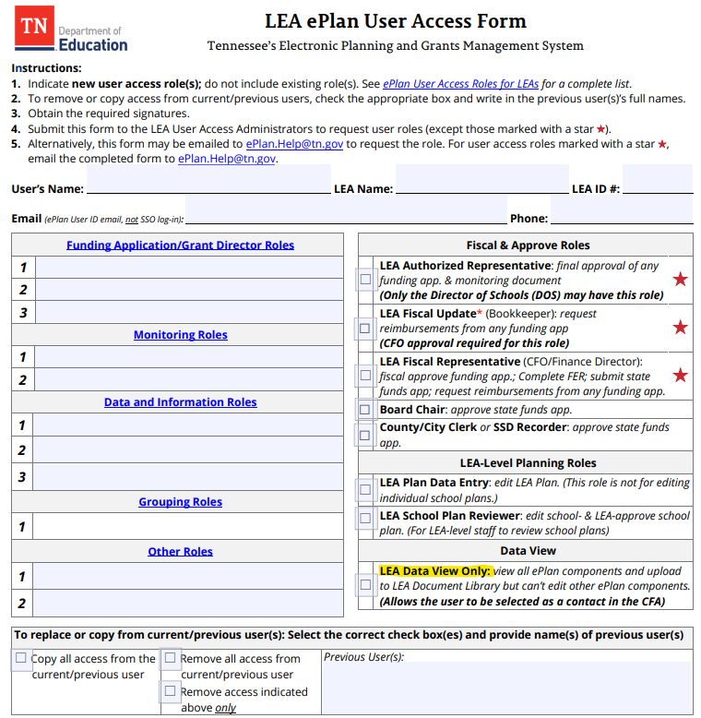

- Select the LEA Document Library from the main menu.

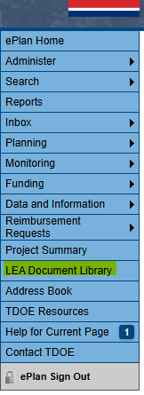

- To open the 2027 LEA Document Library, click on 2027. Then click the + in front of the 2027 as shown below.

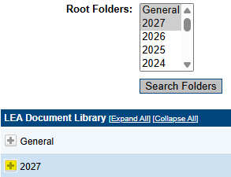

- Click the + to open the Significant Disproportionality folder.

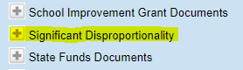

- There are 3 folders that contain the Determination Letter, Data Files and Appeals.

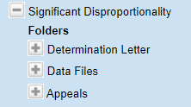

- Click the + to view the documents that have been uploaded.

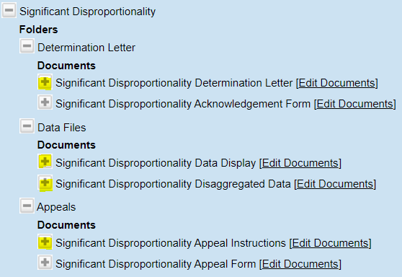

- Click on the Edit Documents to download or upload documents.

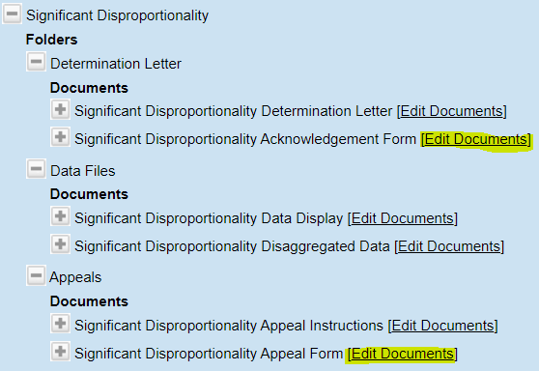

- Templates can be downloaded after clicking on the Document Template as shown below.

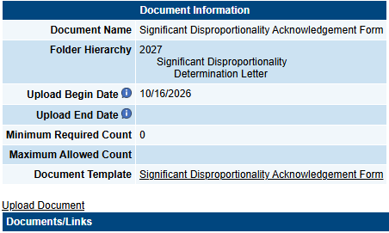

- To upload a document, click on the Upload Document as shown below.

