





ePlan General Technical Application Guide
Tennessee Department of Education | December 2022

Contents
Introduction 3
ePlan User Access 3
Workflows 3
ePlan Application 5
Accessing the Application 5
Saving Funding Application Pages 6
Application Sections and Pages 7
Change Log 7
History Log and Create Comment 8
Allocations 9
Cover Page 9
Budget 9
Program Details 13
Program Assurances 13
Related Documents 14
Checklist 14
Validations 16
Submission 17
Printing in ePlan 17
Troubleshooting 19
User Access 19
Validation Messages 19
Post-Submission 19
Inbox 20
Reimbursement Requests 20
Appendix A: Available Account and Line Numbers 21

Introduction
Organizations apply for grants through ePlan funding applications. Funding applications are created for one or more grants for a fiscal year. This guide gives an overview of general application features.
Guidance for individual funding applications is typically provided in a specific funding application’s Technical Application Guide. These guides include an introduction section describing the purpose and intent of the program, relevant background information about the funding source such as funding legislation, information about application timeframes and deadlines, budget information, and required information for the application. Additional information regarding periods of performance, carryover of funds, state allocations, and matching fund requirements is included as applicable.

ePlan User Access
All users must have the correct ePlan user access role to access and complete applications. Users with existing ePlan access can verify current user access roles in the Address Book. To view existing access, visit ePlan.tn.gov, navigate to the Address Book and LEA Role.
New ePlan users and existing ePlan users who need to request a User Access role must request the additional role using the appropriate ePlan User Access Form. Access the form by navigating to eplan.tn.gov > TDOE Resources > 1. User Access Forms and select the correct form according to organization type, or click on the links below:
- ePlan User Access Form for a Single Non-Public School
- ePlan User Access Form for Multiple Non-Public Schools
- ePlan User Access Form for LEAs
- ePlan User Access Form for Charter Schools
- ePlan User Access Form for Community-Based Organizations (CBOs)
Users do not need to log in to ePlan to access TDOE Resources in ePlan. Follow the instructions on the User Access Form, then email the completed form to ePlan.Help@tn.gov to request additional access roles. User access requests may take up to two business days to process. Users will receive an email reply when access has been granted.

Workflows
Below are the roles and the order of the workflow steps for a typical application process. These roles and the workflow may vary slightly for specific programs.
ePlan Role | ePlan Function
LEA Grant Director  LEA Fiscal Representative  LEA Authorized Representative | Click Draft Started (or Revision Started for revisions)  Respond to application questions, enter budgets
LEA Grant Director | Click Draft Completed (or Revision Completed for revisions)
LEA Fiscal Representative  (CFO or treasurer) | Click LEA Fiscal Representative Approved  (or LEA Fiscal Representative Not Approved)  (may also request funds after TDOE approves application)
LEA Authorized Representative  (Director of Schools) | Click LEA Authorized Representative Approved  (or LEA Authorized Representative Not Approved)
TDOE Program Director  (Department project directors) | Click TDOE Program Director Approved  (or TDOE Program Director Returned Not Approved)

After each status change, ePlan automatically sends a notification email to all users in the LEA who have the ePlan role of the next step in the process. Reimbursements cannot be submitted until approval is received from the TDOE Program Director.

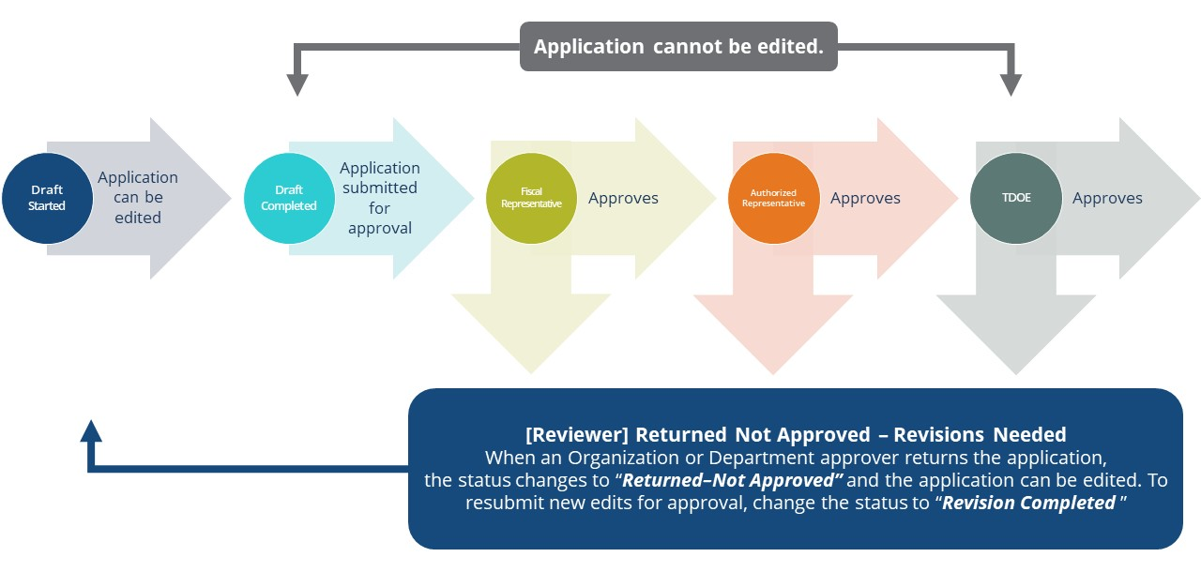

ePlan Application

Accessing the Application
To navigate to applications from the ePlan homepage, hover over the Funding tab on the left menu bar, then select Funding Applications. NOTE: For users with ePlan roles for multiple organizations, return to ePlan home to select the correct organization before proceeding to Funding Applications.
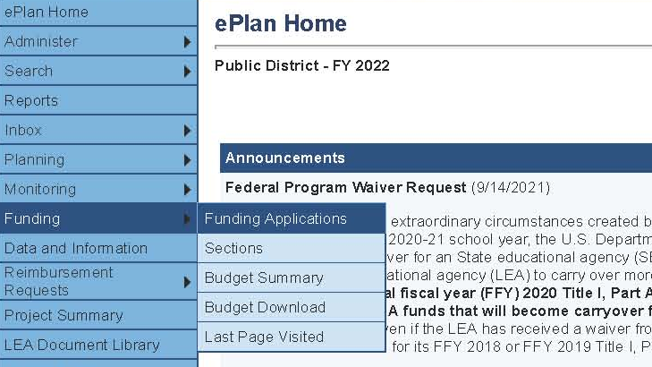
Select the desired fiscal year from the dropdown in the upper left corner of the screen. Funding applications are stored in ePlan according to the state fiscal year (i.e., 2022 indicates the 2021–22 school year). Click on the application name to access the application.
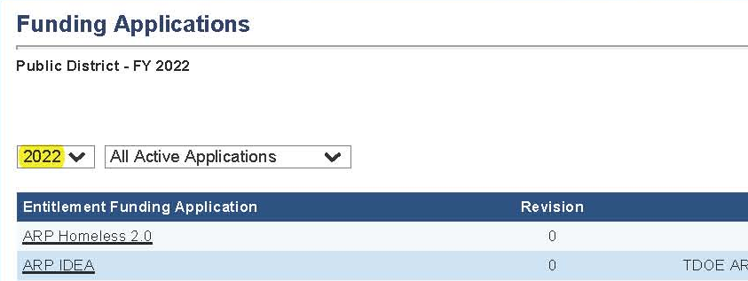
To begin the application, next to Change Status To: click on Draft Started.
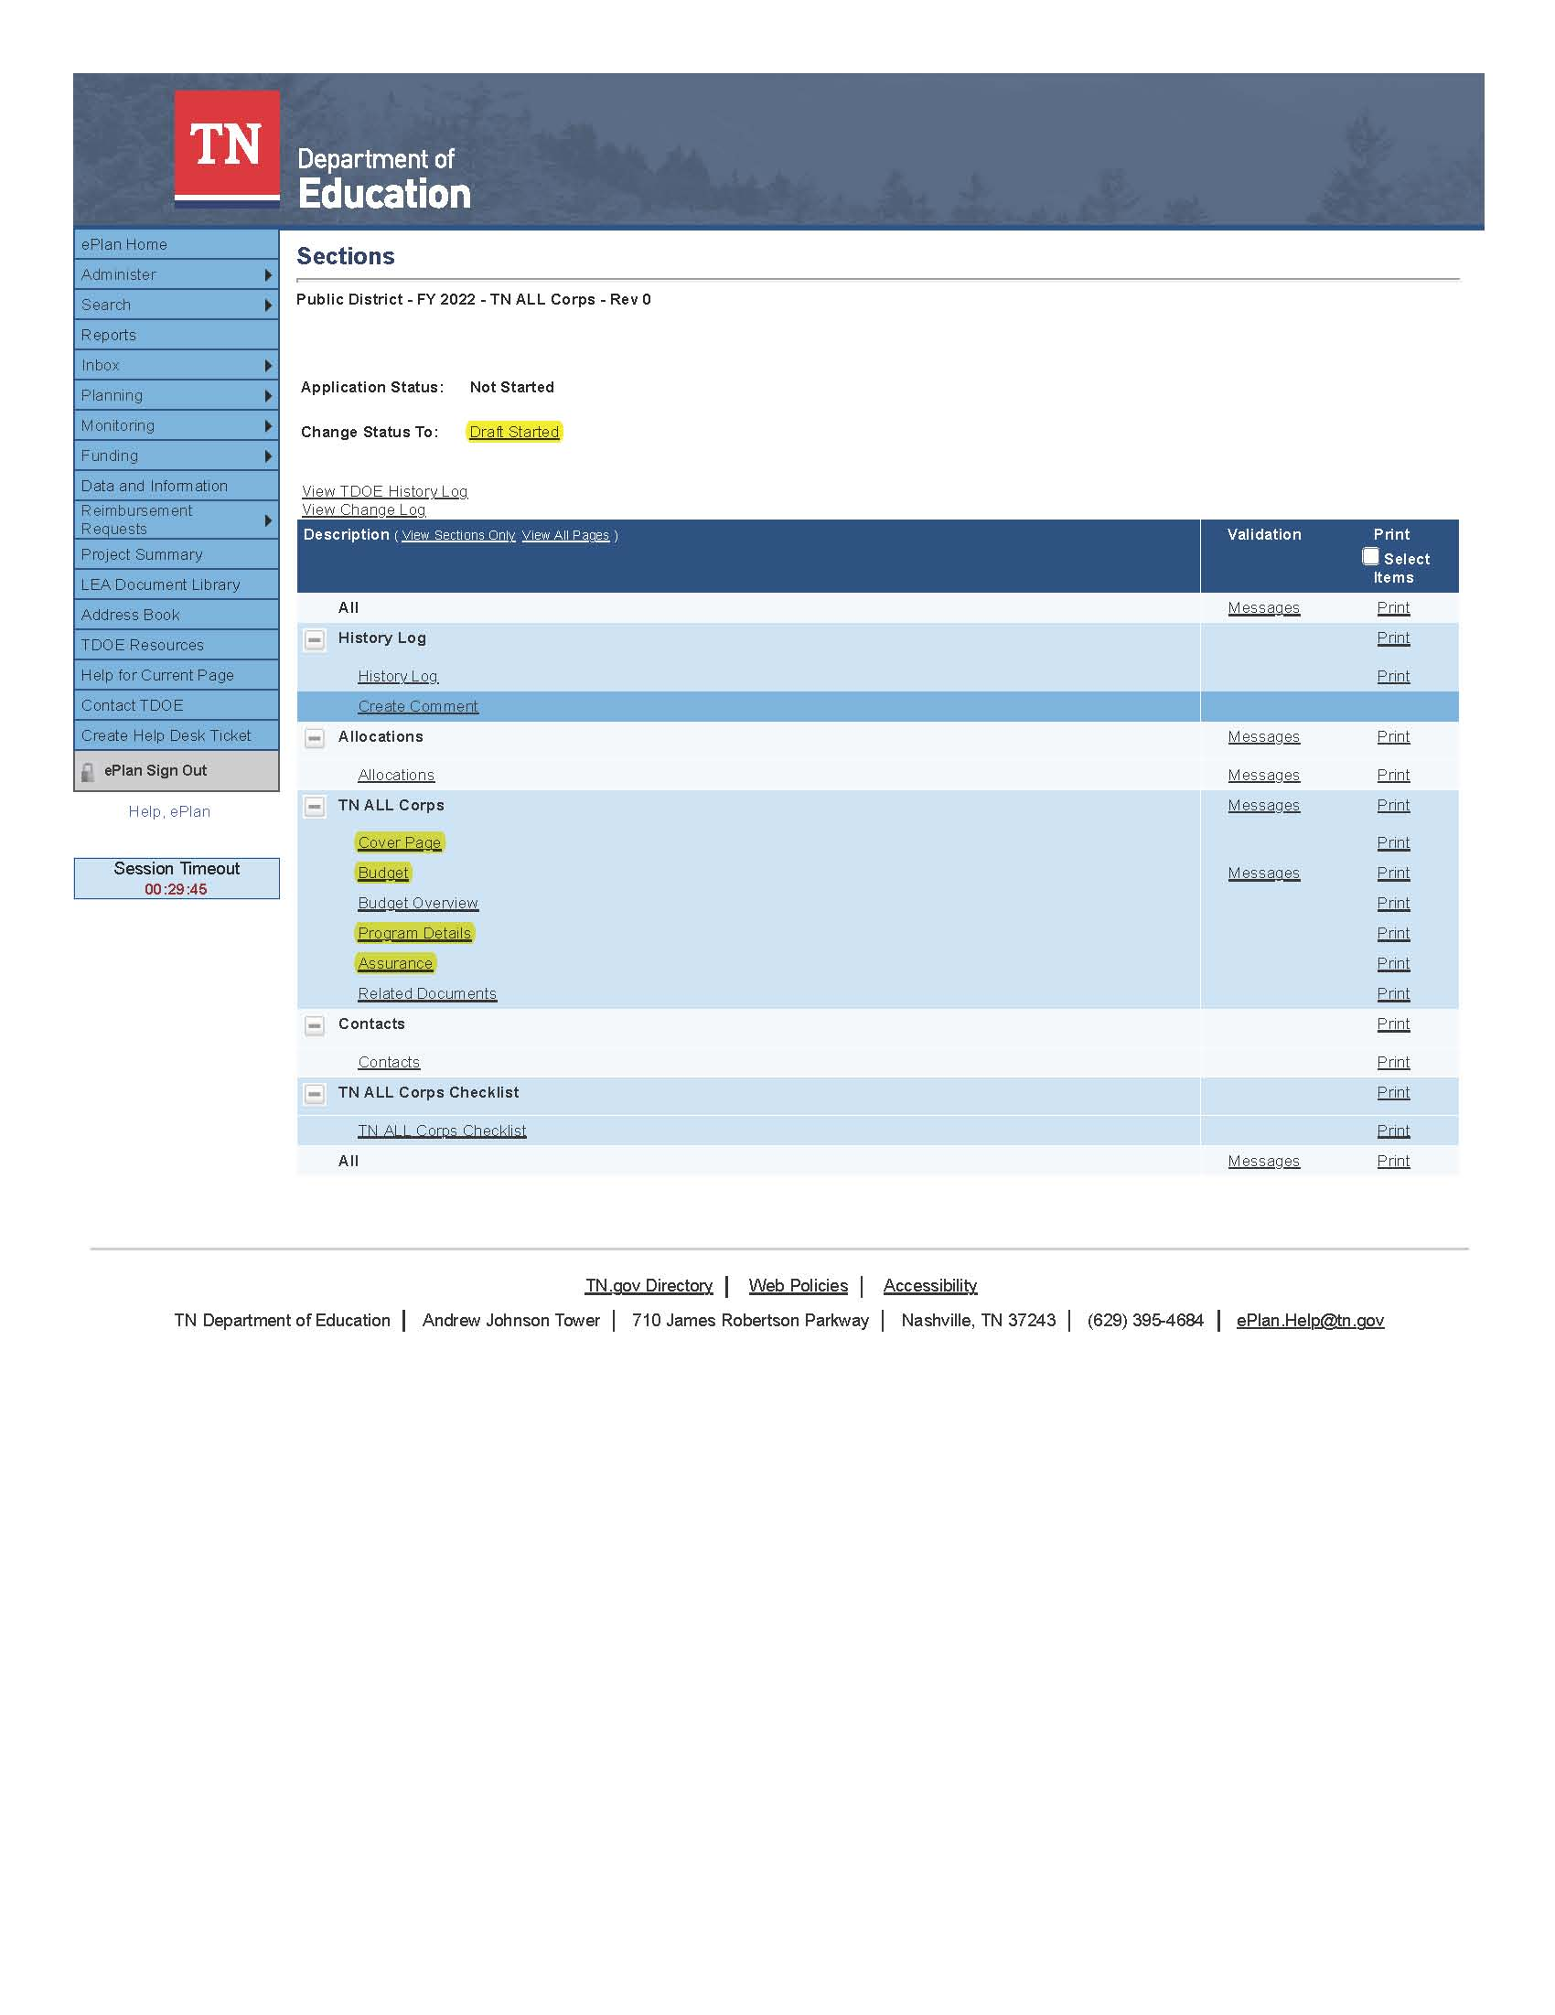
NOTE: Once a draft has been started, users may wish to access previous applications. To access previous applications, return to Funding Applications and select the appropriate prior year.

Saving Funding Application Pages
After working in a funding application, users must click the Save and Go To button, then ensure that the page has finished saving before closing ePlan or leaving the page.
Users can tell that the page has not saved when the browser’s spinning wheel or loading icon is still occurring. The screenshot below shows an example of a page that has not finished saving. Please make sure that the browser’s loading icon is no longer spinning before closing the page.
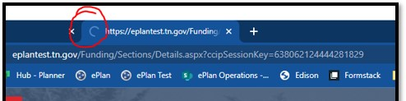
The best way to see if a change to the application was saved after leaving the page is to review the Change Log. The Change Log for the application can be accessed from the Sections page.
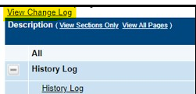

Application Sections and Pages
The Sections page lists all the available sections and pages within an application such as: Change Log, History Log, Create Comment, Cover Page, Budget, Program Details, Assurance, Related Documents, and Checklist. Individual funding application guides indicates which pages are applicable to each specific program application. The Sections page is helpful in navigating to the specific sections and pages which must be completed.

Change Log
The Change Log may be accessed on the main sections page for every funding application. It lists every change or update since the previous status. This helps users identify changes that have been made to the application since they last viewed it. More information about the Change Log is available in the ePlan User Manual.
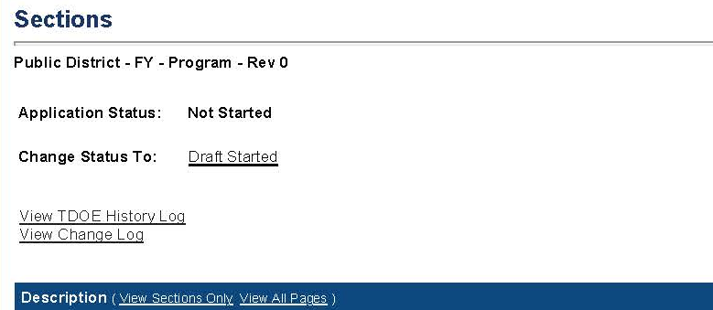

History Log and Create Comment
The History Log contains a record of status changes and comments made on the application. ePlan users may want or need to create a comment in an ePlan funding application for one of the following reasons:
- To provide an explanation as a part of the application’s history.
- To provide information that a user cannot add into the main application due to the application’s current status (users can only edit applications that are in a Draft Started or Revision Started status.)
ePlan creates a running record of all comments. Any comment created and saved in an ePlan funding application will always be available as a part of the funding application’s history log.

To Add a Comment in a Funding Application:
- Navigate to the funding application’s main Sections page.
- To navigate to the main funding application page from other pages in the application, click Go To and Sections as shown and highlighted below.
- Select Create Comment from under the History Log on the main section page as highlighted in the screenshot below to navigate to the Create Comment page.
- On the Create Comment page, type your comment in the box.
- If desired, a hyperlink can be inserted in a comment by clicking the hyperlink icon.
- To send an email notification of this comment to recipients check the box next to Send Email to ePlan Contacts below the main comment box.
- Sending an email notification is not required to create the comment.
- If no email notification is needed, click Save and Go To to exit the page. The comment is now a part of the Funding Application History Log for everyone to view.
- To send an email notification: Select the recipients to receive notification of the comment from the lists provided and then click Add.
Available Contact Groups
LEA Contacts by  Funding Application | Available if a contact is selected on the applications contact page. Not all funding applications have contacts on the contact page.
LEA Contacts by Role | Current users with the applicable role
Other LEA Contacts | Additional contacts for an LEA
TDOE Contacts | State users that can complete various ePlan functions.
TDOE Miscellaneous  Contacts | Lists every State ePlan User by name
Additional Recipients | Allows you to type in any additional email addresses manually
- It is a good practice to send a copy of your comment to yourself to let you know when the message has been delivered.
- The Recipient Summary shows who will receive the email.
- Clicking Save And Go To will send the comment notification.
- Comments with email notifications can be accessed from the Inbox on your ePlan tab in addition to the history log of the funding application. Additional information about Inbox functionality in ePlan is available in Troubleshooting, Inbox.

Allocations
The Allocations page in ePlan indicates the total amount awarded by the grant program to the grantee. For entitlement grant programs, the Allocations page will be populated with a total budget amount at the time of application and the subsequent Budget pages will typically need to be completed to indicate how the total allocation will be allocated across specific budget accounts and line items. For competitive grants, the Allocations page will not typically be populated until grant awards are made and a proposed budget will be entered by the user on the Budget pages. Grantees will receive a notification of award and specific instructions for formulating a budget revision to reconcile the proposed budget to the total allocation which is entered on the Allocations page at the time of award.

Cover Page
The Cover Page typically requires entry of general organization information: the ID Number, Organization Name, Official Address, and name and email and phone contact information for organization and program points of contact. For federal funding applications, this page also requires the LEA to provide the Unique Entity Identifier (UEI) set up at SAM.gov. Once all fields are complete, hover over the Save And Go To button and click on Sections to return to the Sections page.
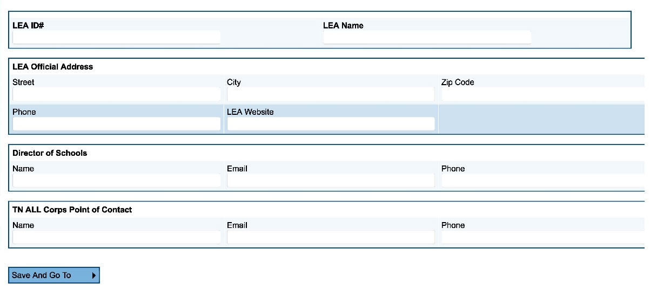

Budget

Allowable Use of Funds
Individual funding application guides include a brief explanation of allowable and unallowable costs. All expenses must be necessary and reasonable for performing grant activities. A full list of account numbers and line items that are eligible to be budgeted may be included in an appendix for further guidance.

Transfers Out and Indirect Cost
Indirect cost represents the expenses of doing business that cannot clearly link to a specific grant, contract, project function, or activity, but are necessary for the general operation of the organization and the activities it performs. These costs cannot attribute directly to any grant because the time and effort spent are not measurable. Users may choose to budget for indirect cost for some funding programs. Indirect cost is available on each Budget page in account number 99100 – Transfers Out.
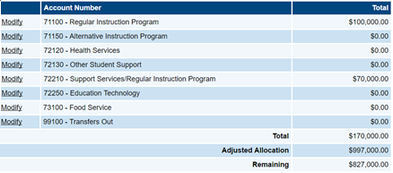
ePlan provides automated information regarding the maximum amount permitted for indirect cost within each grant.
- Eligible funds budgeted in all accounts are totaled at the top of the Budget page on the Total Contributing to Indirect Cost line.
- Organizations have an individualized, agreed-upon indirect cost rate that is preloaded into ePlan each year or a standard rate for the funding program will be applied.
- Organizations cannot exceed the Maximum Allowed for Indirect Cost. If the total amount budgeted in account number 99100 is more than the maximum allowed for indirect cost, the user receives a validation error and cannot submit the application.

Entering the Budget
Depending on the funding application, Users can make changes to grant budgets using the following methods:
- Adding Budget Details Manually,
- The Copy Last Year’s Budget Detail Function, and
- The Upload Budget Data/Download Budget Data Function

Adding Budget Details Manually
To manually enter each budget line item:
- For each budget line that the organization plans to use, click Modify located to the left of the account number to open the Budget Detail page for that line item.
- On the Budget Detail page for the line item, click Add Budget Detail.
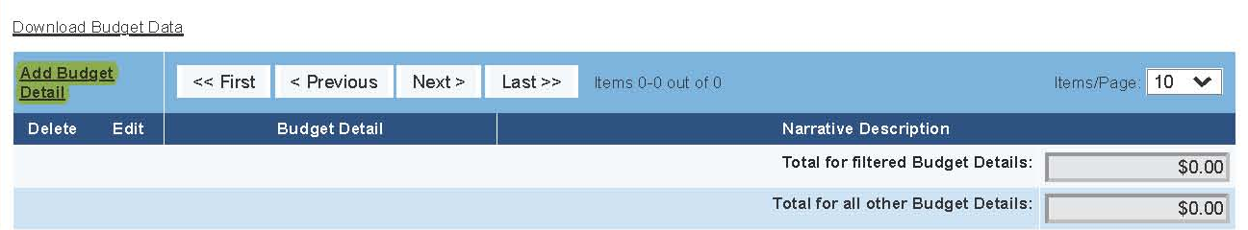
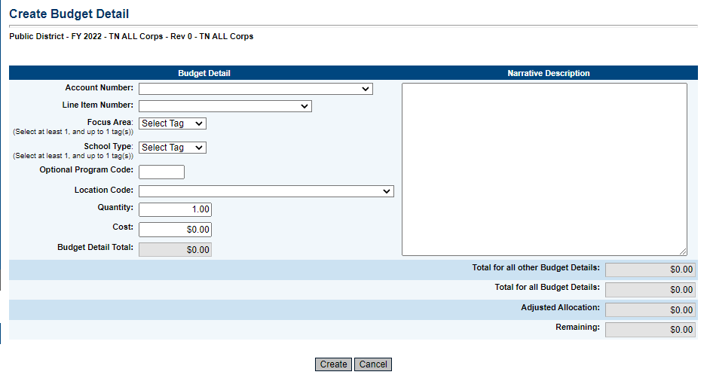
- For each Budget Detail:
  - The Account Number auto-populates for the account that is being modified.
  - Select the appropriate line item number from the dropdown menu. A complete list of available line items should be included in a table or in an appendix to the program application guide.
  - Program-specific uses of budget tags, such as Focus Area or School Type, as well as Optional Program Codes and Location Codes will be included in a table or in an appendix in the individual funding application technical guide.
  - Add a narrative description for each entry.
  - Enter the Quantity and Cost for the Budget detail. The quantity is most commonly 1.00.
  - ePlan auto-calculates the Line Item total as Quantity multiplied by Cost.
- Continue to add additional Budget Details as needed for the budget line item.
- To edit existing Budget details, click the pencil icon. To delete an existing Budget Detail, click the trash can icon.
- Click Return to navigate back to the Budget page and repeat this process for each budget line. ePlan auto-calculates the budget totals as budget items and details are entered. When award amounts are predetermined, ePlan deducts the budgeted amounts from the awarded allocation.
- Once complete, confirm that the total amount is accurate or that the Remaining area at the bottom of the Budget page is $0.00.

Copying Last Year’s Budget Detail
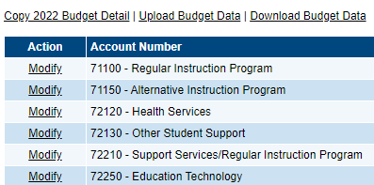
On some funding applications, Users may choose to copy the previous year’s budget line items and narrative descriptions into the current year’s application. Once copied, users only need to make changes where dollar amounts and narratives have changed since the previous year.
The decision to copy a previous year's budget must be made before entering the current year's budget information. If a user makes a single budget entry, the link to copy budget details becomes unavailable.
To copy the previous year’s budget, click Copy [2022] Budget Detail. Click the verification link Copy

Upload Budget Data and Download Budget Data
The Budget Upload/Download function on the budget page allows users to download budget files as spreadsheets and then create, edit, or delete the contained budget detail data in the spreadsheet file before uploading it back into ePlan. This allows users to do the following:
- Complete data entry faster,
- See large numbers of budget details at one time,
- Create custom reports from budget details using the Excel functions,
- Ask individuals to contribute to application budgets without ePlan access, which the user can upload directly into the Application, and
- Print the budget as an Excel file, including the ability to print filtered data, such as budget details for a specific school.
Any user who can view the budget page of the application can use the download budget function, including the public in the case of approved applications. Only users with the user role access that allows changes to the budget page may upload a file into the application. Uploads, like other budget changes, can only occur when the funding application is in an editable status (Such as Draft Started or Revision Started, or Returned Not Approved. The Upload Budget Data link is unavailable when the application is in a non-editable status. Detailed instructions for uploading and downloading budget data are available here.

Budget Totals
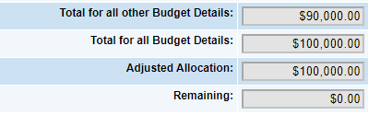
ePlan auto-calculates the budget totals as budget details are entered and deducts the budgeted amounts from the awarded allocation. Users can see the total calculations at the bottom right-hand corner of the Update Budget Detail page
- Once all budget details are complete, confirm that the amount in the Remaining area is $0.00.

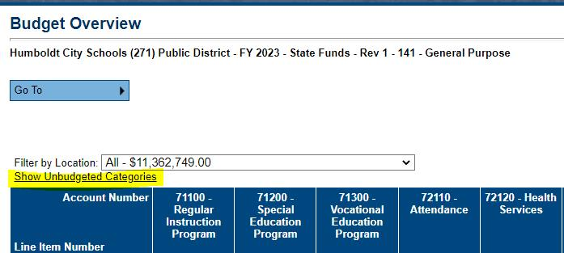
Budget Overview
Every funding application will have a standard Budget Overview page that shows a summary of how the grantee has proposed allocating the grant funds by line item number.
The Show Unbudgeted Categories link will show every line item that is available to be budgeted.

Program Details
As applicable, Program Details pages include application questions specific to the funding program. Application questions may require numeric or narrative responses or require selection from drop down or checkbox options. Each funding program application guide lists the questions specific to the program included in the Program Details page as well as any limitations on responses such as word or character count limits.
Due to system timeouts and the need to frequently save information entered in ePlan, users can review application questions included on the Program Details page and formulate responses in a word processing or spreadsheet document. By copying and pasting responses from a word processing or spreadsheet document into the application, users can avoid losing unsaved responses when timeouts occur.
Occasionally, program questions are provided to users prior to the application opening, and/or prior to final grant allocations being loaded into ePlan. When this occurs, users can begin answering program details questions before entering the budget into ePlan.

Program Assurances
Users must review all program assurances thoroughly. All items specified are requirements of the program, legislation, or regulation. Two types of program assurances can be used in ePlan funding applications.
- Embedded Program Assurances
- Assurance files

Embedded Program Assurances:
Embedded program Assurances are built into the ePlan funding application on Program Details pages, or on individual Program Assurances pages. By checking the assurance check box, the user affirms that they have read and understand all requirements and that the user assures the state education agency that the user meets each of the conditions detailed in the Assurances.
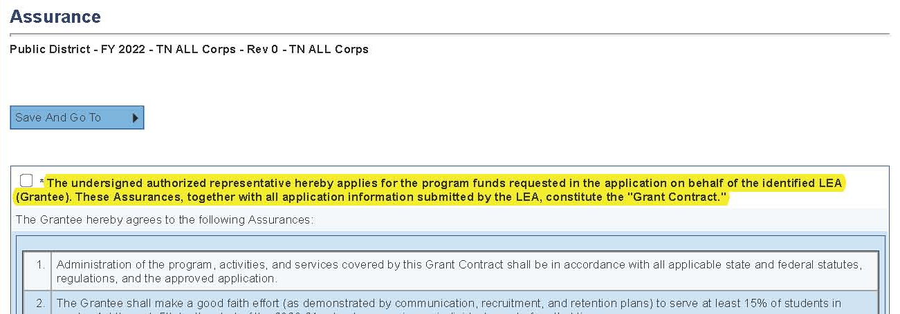

Assurance Files
For some grants, Organizations must provide the Tennessee Central Procurement Office Audit team with an additional set of assurances. This is a file provided as a link at the bottom of the Program Assurances page. Scroll to the bottom of the page to download the file. After following the instructions for the file, check the second box. Hover over the Save And Go To button and click on Sections.
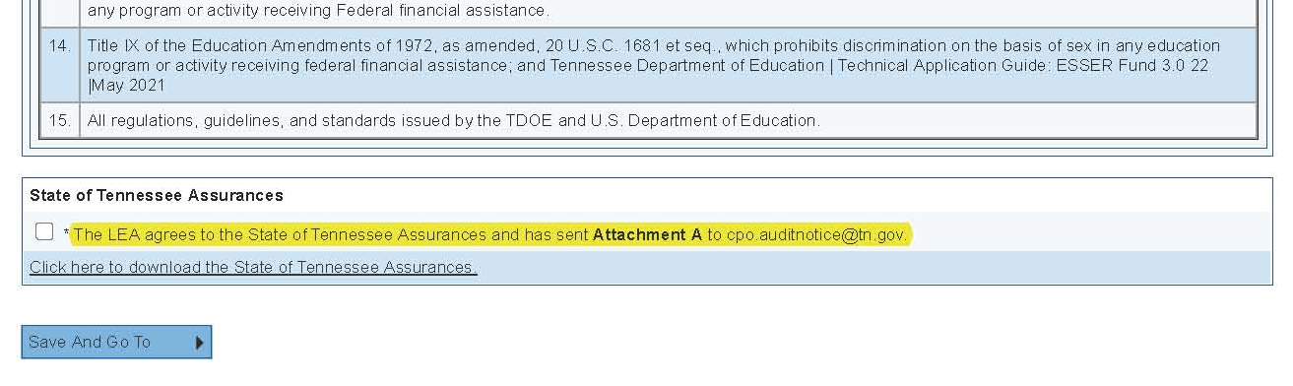

Related Documents
The Related Documents page allows users to upload external related documents. Each funding program application guide lists any required and optional related documents. Headers in the Related Documents section indicate if the document is required or optional. If a document is required, ePlan prevents submission of the application without an upload.
The Document Template column provides links to download templates or forms for application items, if applicable. If N/A appears in this column, there is no required template for that specific item. Upload content in any format.
- Download the document template (if applicable), complete the document, and click the Upload New link to begin the upload.
- Click the Choose File button to browse for the document.
- Upload the document and enter a specific name for the document.
- Click Create to upload the document.

Checklist
Some funding applications may include a Checklist section purely for informational purposes. Other applications may use the Checklist section functionality to provide feedback to users and communicate corrections that must be made to the application before it can be approved. Individual funding application guide indicate whether a Checklist is included for informational purposes or as a part of the review process.
When the Checklist is part of the review process, each section is designated with one of these statuses:
- Not Reviewed: No review occurred.
- OK: The section has no corrections and is approvable.
- Coordinator Reviewed: The section has been reviewed by the coordinator.
- Attention Needed: The section has items that need to have corrections completed.
Users should review the Checklist for comments from each application reviewer, if applicable, and for the program section.
After submission, the department reviews the application and marks each section as OK, Not Applicable, or Attention Needed. If the application contains no items that are marked as Attention Needed, the application is approvable.
If the application contains items that are marked as Attention Needed, the application will be returned to the user with a status of Not Approved. The user must review the checklist for items that are marked Attention Needed and make the necessary changes to those items. Only the checked items in the areas marked Attention Needed need correction. Each section marked Attention Needed includes notes to explain items needing attention. The user should check for notes and additional comments.
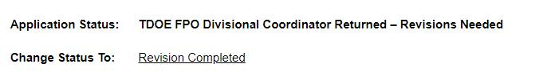
Once the user has made the necessary adjustments, the user resubmits the application for approval. If the department determines that the area is corrected, Attention Needed will be changed to OK by department leadership. If the items needing attention still have not been corrected, the application will be returned again with a status of Not Approved.
Applications that contain no items that are marked Attention Needed can be approved.

Validations
ePlan runs funding application validations as checks to help users complete the funding application correctly. Users can view validation messages from the Sections page, by clicking “Messages” in the Validation column. Users can view all validation messages in the application, or validation messages for the individual section or page.
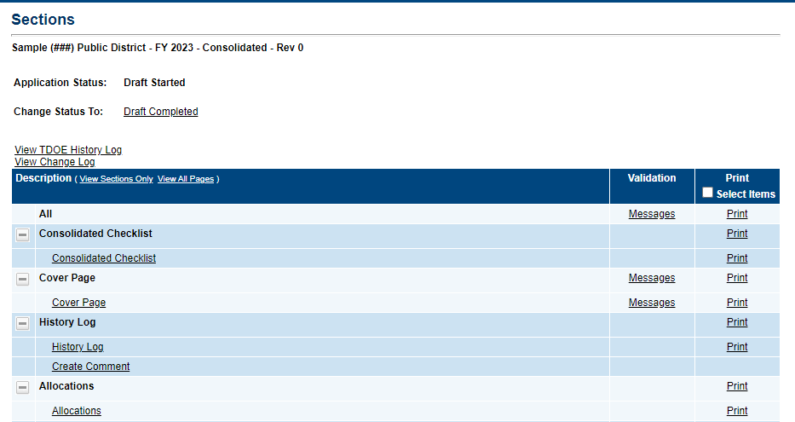
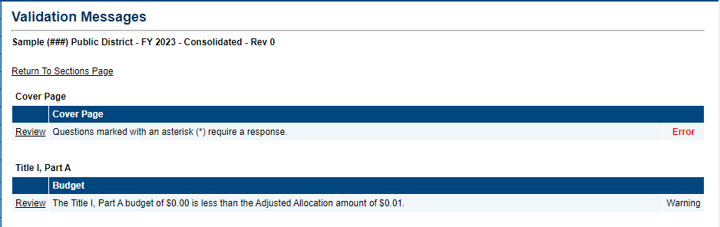
On the Validation Messages page, items marked Warning are validations that users are not required to address prior to submitting the application. Examples of warnings are not uploading an optional related document or budgeting an entire allocation.
Items marked Error are incorrect, and users must address each one before submitting the application. Examples of errors are (1) budgeting for more than the allocation, (2) budgeting more indirect cost than is allowable, (3) not budgeting in a section where there is an allocation, (4) not uploading a required related document, and (5) not responding to a required question.
- If the user does not address all Error validations, ePlan will not allow a user to submit the application. Click on the Review link to go to the identified page to make corrections.
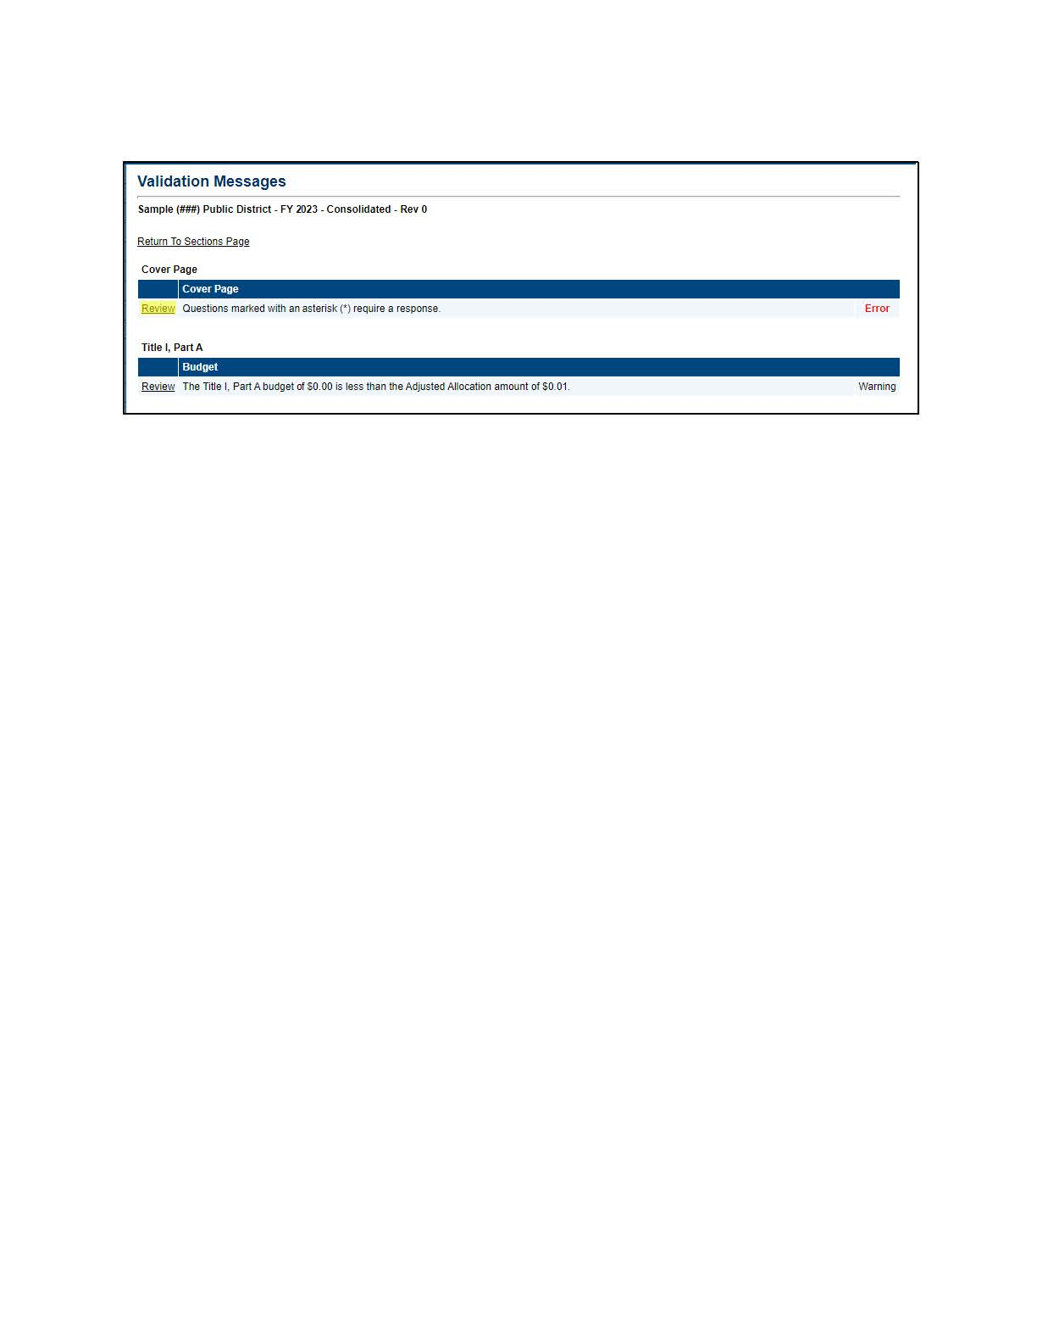

Submission
When all application sections and pages are complete and any validation errors are cleared, the application is ready for submission and the approval process. Refer to the ePlan User Access section of this guide or the individual funding application guide for the approval workflow.
To submit the application for review, the user changes the application status on the Sections page to Draft Complete. This generates an email to the next user in the approval workflow who must review the draft and click Approved (or Not Approved) at the top of the Sections page.
Once the application receives approval from the TDOE Program Director, users may begin submitting reimbursements

Printing in ePlan
Users may print or download a PDF from the Sections page.
- To print the entire application, click the Print link across from the word All at the top of the Sections page. Print requests do not include any uploaded related documents.
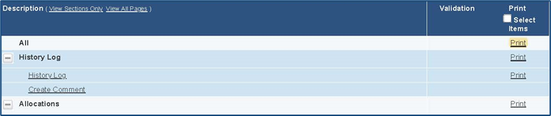
- To print a single page, click on the Print link across from the name of the page.
- To print an entire section, click on the Print link to the far right of the section name.
- To choose multiple pages, check the Print Select Items box at the top of the print column to select more than one page. The Print links appear as checkboxes. Select all text boxes for the desired print request.
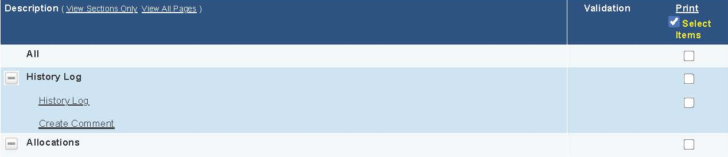
- Select the checkboxes and click Print at the top of the column.
- The Print Request screen pops up. If necessary, Users may rename their print job here.
- Click Print. The Generating Document screen appears. The system takes 20–30 seconds to generate the print job. For larger files, expect an email from the ePlan system when the file is ready to download.
- After ePlan generates the print file, click Return to Funding Applications.
- ePlan generates a PDF which appears at the top of the page from the TDOE Resources menu item in ePlan. The PDF link remains in TDOE Resources for five (5) days. Users may use the Delete links to remove any print jobs if desired.
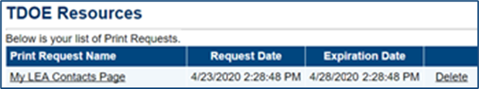

Troubleshooting
The following are answers to common questions about ePlan application functionality.

User Access
If an ePlan user is not able to work in an application, it is usually due to one of these three reasons:
- The user is not using the Google Chrome browser. For best results: always use Google Chrome to access ePlan. ePlan does not have the same functionality in other browsers.
- The application is not in the right work step or status. Users can only edit an application when it is in Draft Started or Revision Started status.
- The user does not have the right role to work on the application. When hovering the cursor over Change Status To options, a tooltip appears that indicates the roles with access to make the status change. This tooltip will list the names of individual users associated with each permitted role. Users can also access the address book to see which roles an ePlan user has.
ePlan’s address book for each organization contains a list of every user that has an ePlan role.
- The LEA Role Contacts list all the roles. If the role is not listed in the address book, no one has been assigned to that role.
- The LEA Funding Application contacts are contacts selected for a funding application.
  - A contact is not the same as a role. A role assigns access to complete a task in ePlan.
- User Access forms are in ePlan’s TDOE Resources in the User Access Form folder.
  - Users do not need an ePlan role to access TDOE Resources.
See ePlan User Access for more information about the ePlan status workflow and user roles.

Validation Messages
- This feature shows any errors that will prevent an application from moving forward.
- Click the messages under Validation on the Sections page to see any errors or warnings.

Post-Submission
When users need to revise an application after changing the status to Draft Completed prior to the submission deadline, contact the next approver in the workflow and ask that they change the status to Not Approved to return the application access to the previous user in the workflow. If the application has proceeded through the workflow to the TDOE Program Director, users can contact the program director or ePlan Help to request that the application be returned to the previous step in the workflow.
A complete list of ePlan program contacts is available here.

Inbox
Several ePlan functions automatically generate emails which the system sends to users. The Create Comment function prompts ePlan to send an email message to the selected recipients. And, System Notifications are sent to users because of a Status Change to support Workflows.
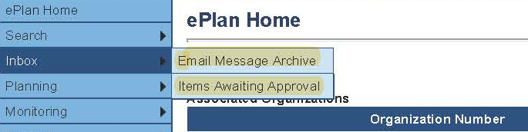
All email messages sent or received by a user through ePlan can be accessed from the Inbox. The Inbox section of ePlan contains the Email Message Archive and Items Awaiting Approval. The Email Message Archive will contain all emails sent to or received from another ePlan user through the system. Users may select the time period to display. Messages received by the user will appear first; scroll down to the lower half of the page to view sent messages. Comments with email notifications can be accessed from the Inbox in addition to the History Log section of the funding application.
When a System Notification is generated related to a Status Change that requires the user to complete an approval step, users will find these in Items Awaiting Approval.

Reimbursement Requests
- Reimbursement Requests can only be submitted one at a time by a user with the Fiscal Update Role.
- Reimbursement Requests cannot be submitted until the application is approved by the department.
  - Only budget items that have been approved can be requested for reimbursement.

Appendix A: Available Account and Line Numbers
Account Number | Common Expenses Type and Line Items*
Regular Instructional Program (71100)  The Regular Education Program includes activities that provide students in grades K through 12 with learning experiences to prepare them to become productive citizens, family members, and members of the work force. Expenditures for instructing students should be recorded in this program. | 71100-116 Teachers* (e.g. interventionists, CSR teachers, etc.)  71100-163 Educational Assistants*  71100-189 Other Salaries & Wages (e.g. bonuses, stipend, interventionists, instructional facilitators, instructional coaches that serve at one school, etc.)  71100-195 Certified Substitutes*  71100-198 Non-certified substitutes*  71100-312 Contracts with Private Agencies (e.g. virtual/on-line/remote learning subscriptions)  71100-429 Instructional Supplies & Materials (e.g. IXL, CASE assessments, paper, workbooks, calculators, etc.)  71100-499 Other Supplies & Materials: (e.g. staplers, pointers, markers, pencils, etc.)  71100-722 Regular Instructional Equipment (e.g. tables, desks, chairs, computers, iPads, printers, items that cost $100 or more and have a life span of one year or more, and delicate and fragile items such as: Apple TV, Kindles, etc.)  71100-471 Software (e.g. Edgenuity, Ed Galaxy, Achieve 3000, etc.)
Alternative Instruction Program (71150)  Alternative Schools Program is an instructional program designated for students who consistently exhibit behavior that is disruptive to the learning process or violent in nature. This program may also serve at-risk youth with special needs. This program includes activities that deal directly with the interaction between teachers and students in an alternative learning environment. Expenditures placed under this series are similar to the 71100 account number, except expenditures for 71150 are earmarked specifically for alternative educational settings. | 71150-128 Homebound teachers  71150-311 Contracts with Other School Systems  71150-399 Other Contracted Services (e.g. payments to businesses or other school systems for services related to the instructional program)  71150-429 Instructional Supplies and Materials  71140-430 Textbooks - Electronic  71150-449 Textbooks - Bound  71150-471 Software  71150-499 Other Supplies &Materials (e.g. includes purchases for support of classroom instruction.  71150-790 Regular Instruction Equipment (e.g. computers, desks, chairs, machinery, items that cost $100 or more and have a life span of one year or more, etc.)  NOTE: Since students often attend an alternative program from a number of campuses, much of the cost of their materials such as textbooks should be budgeted to the instructional programs from the school of origin. Therefore, all costs associated with alternative programs may not be recorded in this category. Organizations are expected to track direct costs associated with the program.
Special Education Program (71200)  The Special Education Program includes activities that provide learning experiences for students having special needs. This includes PreK as well as elementary and secondary students. Services include activities for varying needs, including educating the gifted and those with learning, emotional and physical disabilities. A student is educated based on an Individual Education Plan (IEP) developed by a team who addresses the particular needs of the student. | 71200-171 Speech Pathologists  71200-310 Contracts with Other Public Agencies  71200-399 Other Contracted Services (e.g. services the LEA may not be able to perform as part of being required by the student IEP)  71200-429 Instructional Supplies and Materials  71200-471 Software  71200-499 Other Supplies and Materials (e.g. may include consumables, replacement of worn-out or deteriorated items that address the unique needs of students to meet IEP requirements, etc.)  71200-725 Special Education Equipment (e.g. specialized desks and chairs, computers and machinery, etc., equipment/materials should have a life span of one year or more)
Vocational Education Program (71300)  The Career and Technical Education (CTE) Program includes instructional activities that provide students with the opportunity to develop knowledge, skills, and attitudes needed for employment in an occupational area. Activities include training both in the classroom and in a supervised work environment. Expenditures placed under this series are similar to the 71100 account number, except expenditures for 71300 are earmarked specifically for vocational education programs. | 71300-189 Other Salaries and Wages (e.g. CTE teachers to provide students with remote learning)  71300-311 Contracts with Other School Systems  71300-399 Other Contracted Services (e.g. CTE payments to businesses directly related to services for the instructional program)  71300-429 Instructional Supplies & Materials (e.g. repair manuals, tools, wrenches, sockets, drills, etc., materials cost under $100)  71300-471 Software  71300-730 Vocational Instruction Equipment (e.g. tools and shop resources that cost $100 or more, socket sets, drills, welders, TIG and aluminum set-ups, air compressors, etc.)
Attendance (72110)  Attendance services are activities designed to improve student attendance at school and which attempt to prevent or to solve student problems involving the home, the school, and the community. Attendance also records and reports student information to the state for funding and other statistical needs. Major categories include personnel, benefits, supplies and materials, and other charges | 72110-105 Supervisor/Director*  72110-130 Social Workers*  72110-162 Clerical Personnel*  72110-189 Other Salaries & Wages*
Health Services (72120)  Health Support Services are activities that provide physical and mental health services that are not direct instruction. Services are also provided for appropriate medical and nursing services as required by individual program needs that include medical supplies, materials, and equipment. | 72120-105 Supervisor/Director*  72120-131 Medical Personnel* (e.g. nurses, nurse consultants, etc.)  72120-189 Other Salaries & Wages*  72120-499 Other Supplies & Materials (e.g. first aid kits, band-aids, creams, ice packs, gloves, hand sanitizer, disinfecting wipes, other personal protective equipment [PPE]. etc.)  72120-599 Other Charges (e.g. qualified disaster relief payments expenses, reimbursement for food delivery, and home office supplies, etc.)
Other Student Support (72130)  Other Student Support includes services to students in addition to attendance and health services. These include guidance services, and evaluation and testing services for Regular Education students, Special Education students, and Vocational Education students. | 72130-123 Guidance Personnel (i.e. counselors)  72130-170 School Resource Officer (e.g. SRO for summer programming)  72130-307 Communication (e.g. online platform for two-way communication between teachers and parents)  72130-499 Other Supplies and Materials (e.g. social-emotional learning materials, student books, and journals, teacher books, and materials to support students, etc.)  72130-790 Other Equipment (e.g. interactive panel technology, assistive technology for students, etc.)
Support Services/Regular Instruction Program (72210)  Regular Education Program includes activities primarily for assisting instructional staff in planning, developing, and evaluating the process of providing learning experiences for students. These activities include curriculum development, techniques of instruction, child development and understanding, and staff training. | 72210-105 Supervisor/Director*  72210-132 Material Supervisor(s)*  72210-136 Audiovisual Personnel*  72210-137 Education Media Personnel*  72210-189 Other Salaries & Wages*  72210-399 Other Contracted Services  72210-524 In-Service (e.g. professional development)  72210-790 Other Equipment (e.g. tables for social distancing)
Support Services/Alternative Instruction Program (72215)  Alternative School Instructional Support includes activities primarily for assisting instructional staff in planning, developing, and evaluating the process of providing learning experiences for students in alternative learning environments. Activities include curriculum development, techniques of instruction, student development and understanding, and staff training. | 72215-123 Guidance Personnel  72215-138 Instructional Computer Personnel  72215-399 Other Contracted Services (e.g. payments to outside consultants for services to the alternative instructional staff support function)  72215-499 Other Supplies and Materials (e.g. supplies for the alternative education instructional support staff)
Support Services/Special Education Program (72220)  Special Education Instruction Support includes activities primarily for assisting instructional staff in planning, developing, and evaluating the process of providing learning experiences for students with special needs. These activities include curriculum development, techniques of instruction, child development and understanding, and staff training. | 72220-124 Psychological Personnel  72220-135 Assessment Personnel  72220-171 Speech Pathologists  72220-196 In-Service Training (intended to pay employees for providing professional development for others)  72220-308 Consultants (e.g. such as behavior consultants, etc.)  72220-499 Other Supplies and Materials (e.g. additional learning platforms to support progress and mastery of IEP goals; support materials to therapy and intervention, etc.)  72250-524 In-Service/ Staff Development (e.g. all costs related to staff development or training for the support of the special education instructional program)
Support Services/Vocational Education Program (72230)  Career and Technical Education Instructional Staff Support includes activities primarily for assisting instructional staff in planning, developing, and evaluating the process of providing learning experiences that give students the opportunity to develop the knowledge, skills, and attitudes needed for employment in an occupational area. These activities include curriculum development, techniques of instruction, child development and understanding, and staff training. | 72230-336 Maintenance & Repair Services (e.g. equipment essential to the program)  72230-399 Other Contracted Services (e.g. payments to outside consultants for services to the career and technical instructional staff support function)  72230-499 Other Supplies and Materials (e.g. materials for CTE instructional support staff)  72230-790 Other Equipment (e.g. expenses for initial, additional, and replacement of equipment such as computers, desks, chairs, etc., lifespan of items should exceed one year)
Education Technology (72250)  Technology services are designed to provide internet and other technical services to support instruction, attendance, health, administration, testing, and other areas as needed. Major categories include personnel, benefits, supplies, materials, and other expenses such as internet connectivity. 72550 should only be used for LEA connectivity/technology infrastructure. | 72250-138 Instructional Computer Personnel  72250-330 Operating Lease Payments  72250-350 Internet Connectivity  72250-470 Cabling  72250-471 Software (e.g., Microsoft Teams, WebEx, Zoom, security software, etc.)  72250-499 Other Supplies and Materials (e.g. replacement of items consumed, worn out, or deteriorated through the use in providing tech service)  72250-524 In-Service Staff Development  72250-790 Other Equipment (e.g., LEA infrastructure for connectivity/technology)
Office of the Principal (72410)  Office of the Principal includes activities concerned with directing and managing the operation of a particular school. Such activities include those performed by the principal, assistant principals, and other assistants while they supervise all operations of the school, evaluate staff, assign duties to staff, supervise and maintain the records of the school, and coordinate school instructional activities with those of the total school system. These activities also include the work of secretarial and clerical staff in support of the teaching and administrative duties. | 72410-189: Other Salaries and Wages (e.g. stipends for additional duties, added summer school responsibilities)  72410-201Social Security  72410-204 State Retirement  72410-212 Employer Medicare  72410-499 Other Supplies and Materials (e.g. expenditures related to the operation of the office of the principal)
Operation of Plant (72610)  Operation of Plant includes activities concerned with keeping the physical plant clean and ready for daily use. These activities include the operation of the heating, lighting, and ventilating systems, and the repair and replacement of operational equipment. | 72610-328 Janitorial Services (e.g. contracted)  72610-410 Custodial Supplies (e.g., regular cleaning supplies, hand soap, paper towels, etc.)  72610-499 Other Supplies and Materials (e.g. supplies and materials services purchased to keep the physical plant open and safe for use)  72610-720 Plant Operation Equipment (e.g. cameras, vacuums, buffers, floor strippers, HVACs, humidifiers, air quality system, boilers, water heaters, etc.)
Maintenance of Plant (72620)  Maintenance of Plant includes activities concerned with keeping the physical plant open, comfortable, and safe for use, and keeping the grounds, buildings, and equipment in effective working condition and state of repair. It includes maintenance and repair of existing buildings and equipment. | 72620-335 Maintenance & Repair Services – Building (e.g. removal of pipes and drains, roof repair, carpet removal)  72620-336 Maintenance & Repair Services - Equipment (e.g. repair of maintenance equipment)  72620-338 Maintenance & Repair Services – Vehicles (e.g. repair and maintenance of vehicles)  72620-399 Other Contracted Services (e.g. maintenance fleet, reserved for items of an ongoing nature such as alarm monitoring and elevator inspections, etc.)  72620-499 Other Supplies & Materials (e.g. tools, tool housing, storage bins/chests, specialized service equipment, etc.)  72620-599 Other Charges (e.g. expenses related to maintenance function that cannot properly fit into 72620 categories)  72620-717 Maintenance Equipment (e.g. high priced maintenance equipment)
Transportation (72710)  Transportation includes activities concerned with conveying students for Regular, Vocational, and Special Educational instruction, as provided by State and Federal law. This includes trips between home and school, and trips to school activities. Transportation includes operation expenses for system-owned vehicles involved in the transportation function. Vehicle servicing, maintenance, and contracts for transporting services should also be recorded in this category. | 72710-105 Supervisor*  72710-142 Mechanics*  72710-146 Bus Drivers*  72710-189 Other Salaries & Wages*  72710-729 Vans and Vehicles
Food Service (73100)  School Nutrition includes activities concerned with providing meals to students and staff in a school or school system. This service area includes the supervision of a staff whose responsibility is to prepare and serve regular and incidental meals, lunches, or snacks in connection with school activities and food delivery. | 73100-105 Cafeteria Supervisor/Director*  73100-119 Cafeteria Bookkeeper*  73100-162 Clerical Personnel*  73100-165 Cafeteria Personnel*  73100-189 Other Salaries & Wages  73100-422 Food Cost  73100-499 Other Supplies and Materials (e.g., silverware packs, disposal containers, portal coolers, etc.)  73100-710 Food Service Equipment (e.g., kiosks, scanners, pin pads, streamers, coolers, etc.)
Community Services (73300)  Community Services includes activities concerned with providing community services to students, staff, or community participants. This includes expenditures for system staff participating in community organizations such as leadership, family resource centers, Families First, extended school programs, and community-sponsored activities. | 73300-189 Other Salaries & Wages (e.g. supervisor/director, other contracted services)  73300-201 Social Security  73300-204 State Retirement  73300-207 Medical Insurance  73300-212 Employee Medicare  73300-355 Travel  73300-399 Other Contracted Services  73300-499 Other Supplies & Materials (e.g. supplies and materials for the community services program)
Early Childhood Education (73400)  The Early Childhood Education Program includes activities that address the educational, health, and social service needs of preschoolers who are three and four years of age to prepare them for kindergarten. The Early Childhood Instructional Support includes teachers, assistants, and others assisting instructional staff in planning, developing, and evaluating the process of providing learning experiences for the preschools. | 73400-310 Contracts with Other Public Agencies (e.g. contracted student support for early childhood)  73400-399 Other Contracted Services (e.g. services unique to a particular student; amounts paid for services for IDEA early childhood, etc.)  73400-499 Other Supplies & Materials (e.g. support for the early childhood education program for IDEA early childhood.)  73400-790 Other Equipment (e.g. computers, desks, chairs, etc., useful life of items should exceed one year.)
Regular Capital Outlay (76100)  Regular Capital Outlay includes activities such as site acquisition services, site improvement services, architecture and engineering services, building acquisition and construction services, and building improvement services. Expenditures under this series include new upgrades to current facilities and plants. | 76100-706 Building Construction  76100-707 Building Improvements (e.g., upgrades and improvements - window replacement, ionization, roofs, HVAC improvements, asbestos removal, tile installation, etc.)  76100-720 Plant Operation Equipment (e.g. equipment needed to operate facilities, new HVAC, etc.)  76100-790 Other Equipment (e.g. Ion Air Purifiers)
Transfer Out (99100)  This represents monies transferred from one fund to another. It should be utilized for normal interfund transfers (i.e. Indirect cost payments, transfers to Debt Service Fund, transfer of supplemental type payments from one fund to another.) | 99100-504 Indirect cost

