ePlan User Audit Instructions
Non-Public Schools
The ePlan User Audit is important to ensure that user access is accurately assigned and to maintain the integrity of the funding and program information that is provided to the department through ePlan. Please refer to the instructions below to complete the ePlan User Audit. The 2025 audit deadline is Sept. 30, 2025.

Topic | Contact
ePlan technical support and user access | - ePlan.Help@tn.gov
User Access Forms | - ePlan User Access Form for a Single Non-Public School  - ePlan User Access Form for Multiple Non-Public Schools

ePlan User Audit Instructions:
- The ePlan User Audit must be completed by the ePlan User Audit Director.
Note: This role was pre-assigned to LEA Authorized Representatives. This role can be added for other ePlan users in the organization by completing the appropriate ePlan User Access Form linked in the resources above.)
- To navigate to the ePlan User Audit from the ePlan homepage, click on Data and Information on the ePlan main menu.
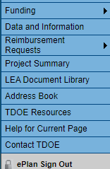

- Select the Fiscal Year 2026 from the drop-down box. Select the relevant ePlan User Audit from the list of
Data and Information tools.
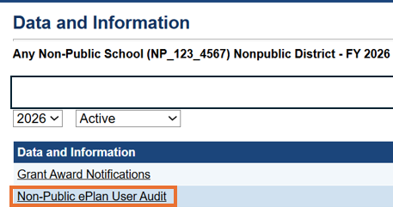
- Click Draft Started. If you are unable to click Draft Started, hover over the Draft Started button to see a list of individuals who have access. Only users with the ePlan User Audit Director roles may click Draft Started.
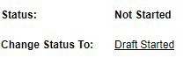

- Click Confirm to change the ePlan User Audit status to Draft Started.

- Select the organization Roles page.
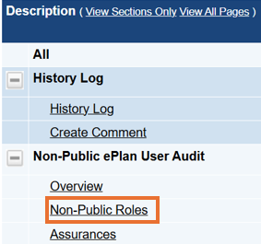
- Roles, Names, and Emails of the individuals who are assigned each role are prepopulated into the data and information tool. Complete the page by reviewing each role.
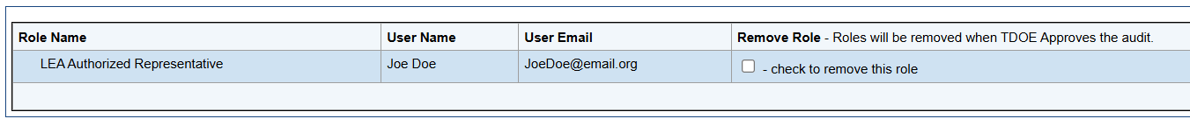

- To request a role be removed from an individual, please click the checkbox in the Remove Role column.
- To request roles for a new user, please navigate to the appropriate User Access Form and follow the instructions on the form. User Access Form links are provided on the page. They are also linked at the top of this document.

- Navigate to the Assurances page by clicking Save and Go To, then [Organization Type] ePlan User Audit, and then Assurances.
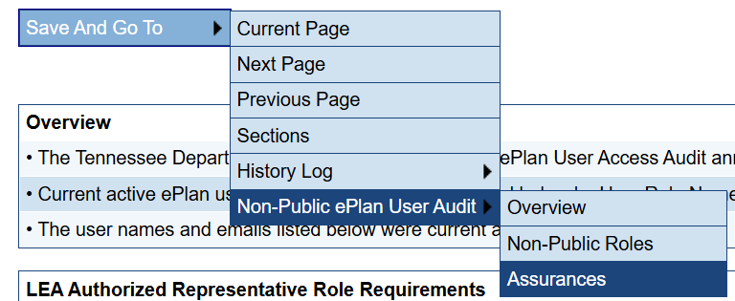

- On the Assurances page, read the assurances and check the box to indicate that the conditions have been met for the ePlan User Audit.
- Return to the Sections page by clicking Save and Go To, then Sections.
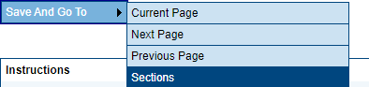
- On the Sections page, the person assigned the LEA ePlan User Audit Director role must change the ePlan User Audit status to Draft Completed.
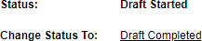
- Click Confirm to submit the ePlan User Audit.

Please note this is the last step.
- After the ePlan User Audit is submitted, the ePlan team will make the requested role changes. The timeline for removal may be up to one month. ePlan User Audit Directors will receive an email when User Access removals are complete.

