**Uploading** Budgets in ePlan

The “Upload Budget Data” feature in ePlan allows LEAs to upload a budget file into the Consolidated Application. This budget file may be downloaded from the LEA’s local accounting system.

* This will save the time it takes to enter budget lines in ePlan budgets.
* This is particularly helpful for districts with large budgets that are different from last year’s budgets.
* Once the budget upload is complete, individual budget items can be changed manually.

Before uploading the file into ePlan:

* The budget upload file must have certain headings in order to process. The files that are downloaded from local accounting systems use these exact headings.
* The file obtained from local government is a text file. This file must be converted into an Excel workbook format. Instructions may be found [HERE](http://tennesseegms.blob.core.windows.net/publicgmsdocuments/8024b6b9-aa49-499c-a29c-a8a60d0bc09b.pdf) (scroll to slide 30).

LEAs may also use the “Budget Upload Template” to format the budget upload file:

* The “Budget Upload Template” uses the correct headings that will allow the file to upload. It is located in TDOE Resources under “Cross-Cutting Fiscal Materials.”

Important to remember:

* Every upload is a “complete” upload.
* Each budget upload replaces all the data that was previously in the budget for that particular grant.

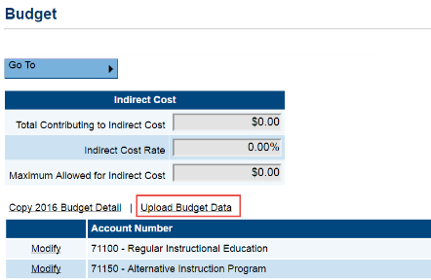

How to upload your budget:

* Once your file is correctly formatted, click on the link that says “Upload Budget Data.”
* Upload each budget individually for each grant (Title I, Title II-A, IDEA Part B, etc.).
* There is no need to create a separate file for each grant. ePlan ignores budget codes where they do not apply.

You will be taken to the “Create Budget Upload” screen.

* Browse to find the file to upload (similar to the process for attaching to an email).
* Then click “Create.”

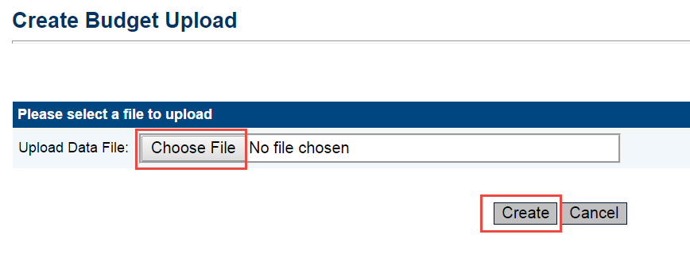

**Uploading** Budgets in ePlan (Continued)

* After clicking on “Create,” ePlan will take you to the “Budget Upload” screen.
* Below are links that appear on the “Budget Upload” screen:
  + “View Messages” - If validation errors exist, the file will not process.
  + “Preview Changes” - This will allow you to view what the upload will look like.
  + “Upload Data File - Click on this link when you are ready to upload the file.
  + “View Data File” - This link will show the Excel file that is currently ready to be processed.
* When everything looks correct, click “Process Budget Upload.”

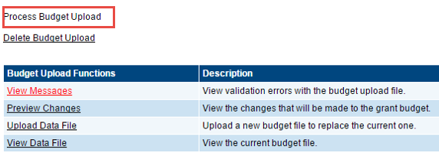

**Copying** Budgets in ePlan

LEAs may automatically copy their 2016 budgets in ePlan into their 2017 consolidated applications.

This is particularly helpful for districts that have budgets that are similar to their last year’s budgets.

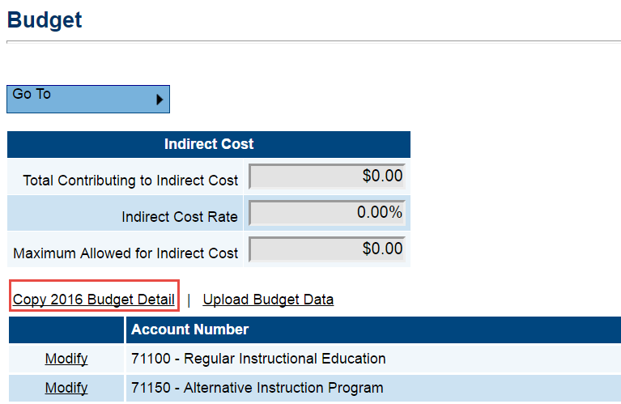Before you begin entering budget data in your budget:

* Decide first if you want to copy over.
* If you do not copy, once you manually enter budget data, the copy function will no longer be available.

If you decide to copy:

* Click on the link that says “Copy 2016 Budget Detail.”
* Once copied, you will only need to make changes where amounts/narratives have changed since 2016.

***Copy each budget individually for each grant (Title I, Title II-A, IDEA Part B, etc.)***

For more information:

* Training materials and the “Budget Upload Template” may be accessed in TDOE Resources in the section titled “Cross-Cutting Fiscal Materials.”
* For general accounting questions or assistance with budgets, uploading, and copying, please contact your regional finance consultant or [Maryanne.Durski@tn.gov](mailto:Maryanne.Durski@tn.gov).