**FY21 Remote Learning Technology Grant Instructions**

Any district user with a district role can upload or download to the LEA Document Library.

* 1. If a user needs a district role, they can find the user access folder by clicking on TDOE Resources on ePlan’s home page, eplan.tn.gov.
  2. This home page can access the TDOE Resources without an ePlan login.
  3. Here is a screenshot of the form, showing a common role of LEA Data View, which allows a user to upload and download from ePlan’s LEA Document Library.

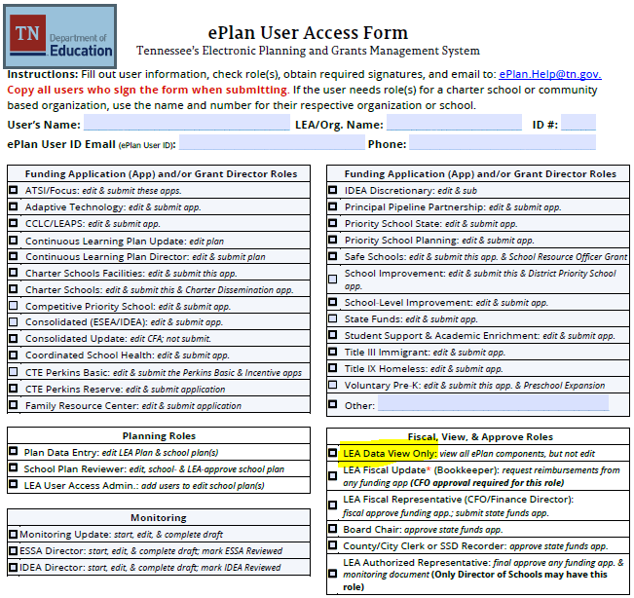

1. Select the **LEA Document Library** from the main menu.

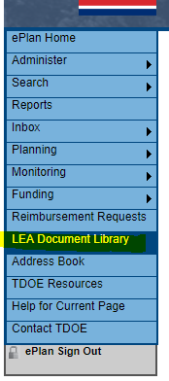

1. To open the 2021 LEA Document Library, click on 2020 and hit **Show Folders**. Then click the + in front of the 2021 as shown below.

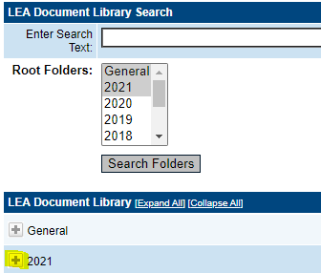

1. Click the + to open this Remote Learning Technology Grant folder.

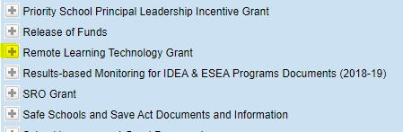

1. There are 5 documents that contain the **Intent to Participate, Application,** **Assurances, Receipts and Supporting Documentation**.

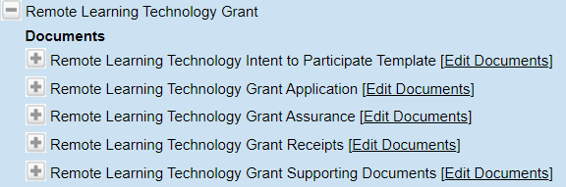

1. Click on the **Edit Documents** to download or upload documents.
   1. ***Please note the application template and upload are in the new Extension 09.04.20 as highlighted below.***
   2. The application with the red **x** is no longer available.

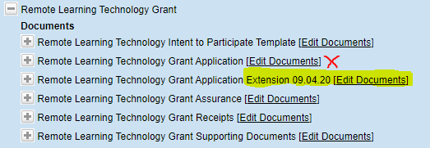

1. The application, assurance and intent to participate have templates that can be downloaded after clicking on the **Document Template** as shown below.

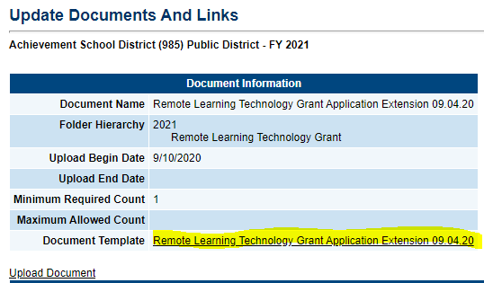

1. To upload a document, click on the **Upload Document** as shown below.

