­



Tristar


ePlan Technical Guide: Parental Leave Data and Information Tool

Tennessee Department of Education | November 2023

Contents

Introduction 3

ePlan User Access 3

Workflows 3

ePlan Data and Information Tool 5

Accessing the Data and Information Tool 5

Saving Data and Information Pages 6

*Change Log*………………………………………………………………………………………………………………………………………… 6

Data and Information Tool Sections and Pages 7

History Log and Create Comment………………………………………………………………………………………………………………….7

*Overview and Instructions*………………………………..…………………………….…………………………………………………………9

Cover Page……………………………………………………………………………………………………………………………………………………9

Quarter Expended Leave Details……………………………………………………………………………………………………………………9

*Related Documents*……………………..………………………………………………………………………………………………………….10

Checklist 10

Validations 11

Submission 12

How to Print in ePlan 13

Troubleshooting 13

User Access 13

Validation Messages 14

Post-Submission 14

Inbox 14

# Introduction

Effective May 11, 2023, Chapter 399 of the Public Acts of 2023 (PC 399), now codified at T.C.A. § 8-50-814, mandates local education agencies (LEAs) grant licensed employees of the LEA six paid workweeks after a birth or stillbirth of the employee's child or employee's adoption of a newly placed minor child. The department will reimburse an LEA in an amount equal to the leave paid by the LEA to the eligible employee.

The **Parental Leave Data and Information** tool can be accessed through the Tennessee Department of Education’s ePlan platform, [ePlan.tn.gov](https://eplan.tn.gov/).

The **Parental Leave Data and Information** tool may be submitted once each quarter. Any omitted requests for reimbursement of parental leave in a quarter may be added to the next quarter’s submission.

# ePlan User Access

All users must have the correct ePlan user access role to access and complete the Data and Information tool. Users with existing ePlan access can verify current user access roles in the Address Book. To view existing access, visit **ePlan.tn.gov**, navigate to the **Address Book** and **LEA Role**.

New ePlan users and existing ePlan users who need to request a User Access role must request the additional role using the appropriate **ePlan User Access Form**. Access the form by navigating to eplan.tn.gov > TDOE Resources > 1. User Access Forms and select the correct form according to organization type, or click on the links below:

* [**ePlan User Access Form for LEAs**](https://eplan.tn.gov/documentlibrary/ViewDocument.aspx?DocumentKey=1511231&inline=true)

Users do not need to log in to ePlan to access *TDOE Resources* in ePlan. Follow the instructions on the *User Access Form*, then email the completed form to [**ePlan.Help@tn.gov**](mailto:ePlan.help@tn.gov) to request additional access roles. User access requests may take up to two business days to process. Users will receive an email reply when access has been granted.

## Workflows

Below are the roles and the order of the workflow steps for the data and information process. These roles and the workflow may vary slightly for specific programs.

| ePlan Role | ePlan Function |
| --- | --- |
| ***LEA Parental Leave Director*** | Click ***Draft Started*** (or ***Revision Started*** for revisions)  Respond to questions, upload files, etc.  Click ***Draft Completed*** (or ***Revision Completed*** for revisions) |
| ***LEA Authorized Representative***  (Director of Schools) | Click ***LEA Authorized Representative Approved***  (or ***LEA Authorized Representative Not Approved***) |
| ***TDOE Parental Leave Consultant***  (Department project directors) | Click ***TDOE Parental Leave Consultant Reviewed*** (or ***TDOE Parental Leave Consultant Returned***) |
| ***TDOE Parental Leave Director***  (Department project directors) | Click ***TDOE Parental Leave Director Approved*** (or ***TDOE Parental Leave Director Not Approved***) |

After each status change, ePlan automatically sends a notification email to all users in the LEA who have the ePlan role of the next step in the process. Reimbursements cannot be processed until approval is received from the TDOE Parental Leave Director.

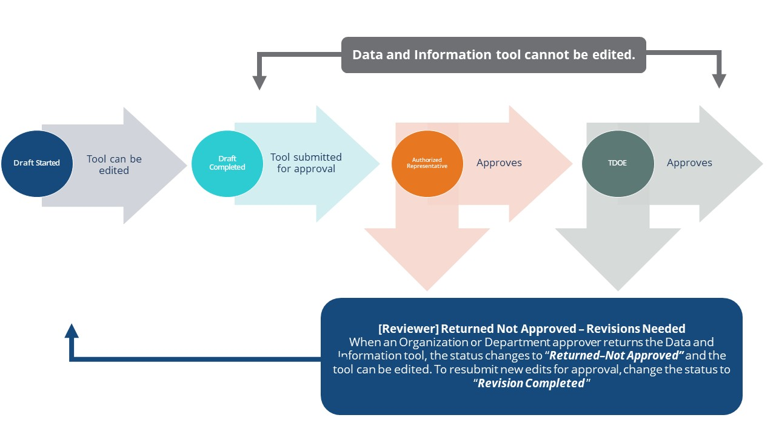

# ePlan Data and Information Tool

## Accessing the Data and Information Tool

To navigate to applications from the ePlan homepage, click the **Data and Information** tab on the left menu bar.

***NOTE:*** For users with ePlan roles for multiple organizations, return to ePlan home to select the correct organization before proceeding to Data and Information.

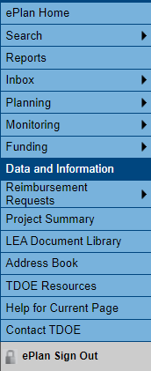

Select the desired fiscal year, 2024, from the dropdown in the upper left corner of the screen. Data and information tools are stored in ePlan according to the state fiscal year (i.e., 2024 indicates the 2023–24 school year). Click on **Parental Leave** to access the tool.

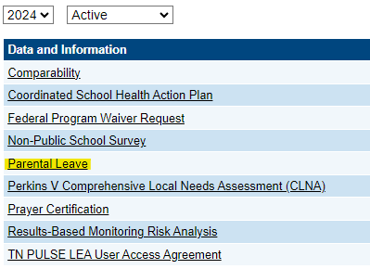

The data and information tool loads to the Parental Leave Sections page. To begin the tool, next to **Change Status To:** click on **Draft Started**. This status may be changed only by the LEA Parental Leave Director.

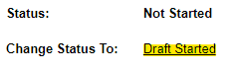

The LEA Parental Leave Director may then click **Confirm** to begin the draft.

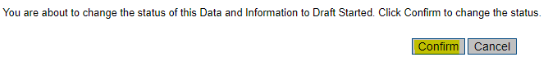

**NOTE:** Once a draft has been started, users may wish to access previous versions. To access previous versions, return to **Data and Information** and select the appropriate prior year.

## Saving Data and Information Pages

After working in a Data and Information Tool, users must click the “Save and Go To” button, then ensure that the page has finished saving before closing ePlan or leaving the page.



Users can tell that the page has not saved when the browsers spinning wheel or loading icon is still occurring. The screenshot below shows an example of a page that has not finished saving. Please make sure that the browser’s loading icon is no longer spinning before closing the page

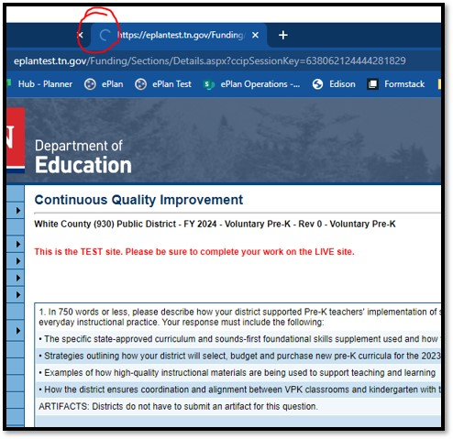

The best way to see if a change to the tool was saved after leaving the page is to review the change log. The change log for the Data and Information tool can be accessed from the Sections Page.

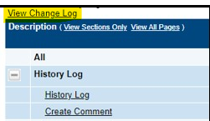

## Data and Information Tool Sections and Pages

The **Sections** page lists all the available sections and pages within the data and information tool: **History Log**, **Create Comment**, **Overview and Instructions**, **Cover Page**, **Expanded Leave Details**, **Related Documents**, and **Parental Leave Checklist**. The **Sections** page is helpful in navigating to the specific sections and pages which must be completed.

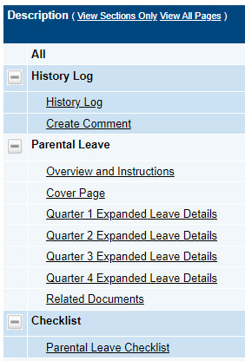

### History Log and Create Comment

The **History Log** contains a record of status changes and comments made on the data and information tool. ePlan users may want or need to create a comment in an ePlan data and information tool for one of the following reasons:

* To provide an explanation as a part of the data and information tool’s history.
* To provide information that a user cannot add into the main data and information tool due to the data and information tool’s status. Users can only edit data and information tools that are in a *Draft Started* or *Revision Started* status.

ePlan creates a running record of all comments. Any comment created and saved in an ePlan data and information tool will always be available as a part of the data and information tool’s history log.

#### To Add a Comment in a Data and Information Tool:

1. Navigate to the data and information tool’s main **Sections** page.

* To navigate to the main data and information tool page from other pages in the data and information tool, click **Go To** and **Sections.**

1. Select **Create Comment** from under the **History Log** on the main section page as highlighted in the screenshot below to navigate to the *Create Comment* page.

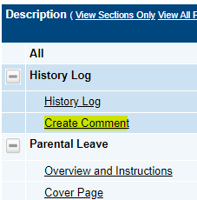

1. On the **Create Comment**page, type your comment in the box.
2. If desired, a hyperlink can be inserted in a comment by clicking the hyperlink icon.
3. To send an email notification of this comment to recipients check the box next to **Send Email to ePlan Contacts** below the main comment box.

* Sending an email notification is not required to create the comment.
* If no email notification is needed, click **Save and Go To** to exit the page. The comment is now a part of the Data and information tool **History Log** for everyone to view.

1. **To send an email notification:** Select the recipients to receive notification of the comment from the lists provided and then click **Add**.

|  |  |
| --- | --- |
| **Available Contact Groups** | |
| **LEA Contacts by** **Funding Application** | Available if a contact is selected on the applications contact page. Not all funding applications have contacts on the contact page. |
| **LEA Contacts by Role** | Current users with the applicable role |
| **Other LEA Contacts** | Additional contacts for an LEA |
| **TDOE Contacts** | State users that can complete various ePlan functions. |
| **TDOE Miscellaneous  Contacts** | Lists every State ePlan User by name |
| **Additional Recipients** | Allows you to type in any additional email addresses manually |

* It is a good practice to send a copy of your comment to yourself to let you know when the message has been delivered.

1. The **Recipient Summary** shows who will receive the email.
2. Clicking **Save And Go To** will send the comment notification.
3. Comments with email notifications can be accessed from the **Inbox** on your ePlan tab in addition to the history log of the data and information tool. Additional information about Inbox functionality in ePlan is available in Troubleshooting, **Inbox**.

### Overview and Instructions

### The Overview and Instructions page summarizes the parental leave law, the reimbursement request process, the pages that must be completed, and provides frequently asked questions and answers. The LEA Parental Leave Director must acknowledge that they have read this page.



### Cover Page

The **Cover Page** requires entry of the Parental Leave Point of Contact’s name, email, and phone number. The number of individuals with requested leave must also be entered. Once all fields are complete, hover over the **Save And Go To** button and click on **Sections** to return to the *Sections* page. *Note: The* ***Amount TDOE Reimbursed*** *will not appear until after the LEA has been reimbursed.*

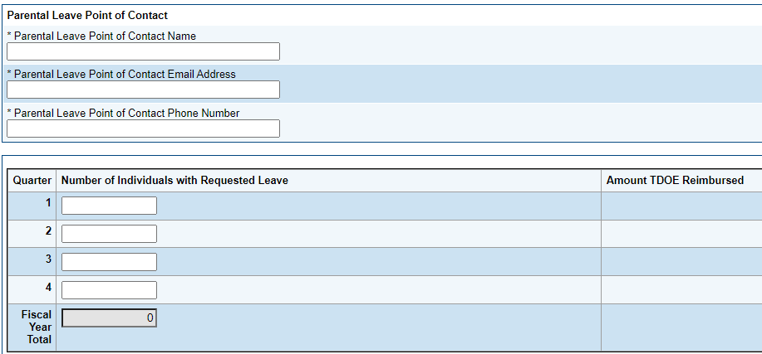

### Quarter Expanded Leave Details

Each quarter will have an **Expanded Leave Details** page that includes information regarding the eligible employee’s leave. Questions may require numeric or narrative responses or require selection from drop down or checkbox options.

Instructions are provided in the **Instructions**section at the top of the leave details page. The instructions must be adhered to for the Data and Information Tool to be approved.

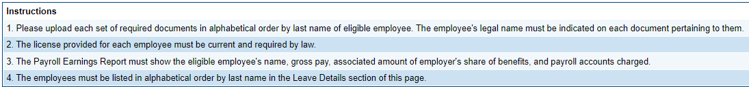

The **Related Documents** section on the leave details page requires documents to be uploaded to support the parental leave reimbursement. All documents are required to be uploaded in order of the employees’ last name.

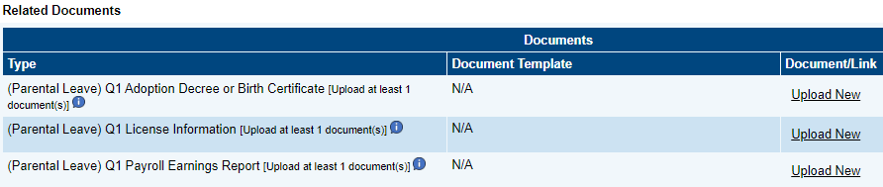

**Quarter Leave Details** must be entered below the Related Documents section. Each row captures the required information for the eligible employee. All fields are required to be completed. To add a new row for additional employees, click on *Add**Row*.

The LEA Parental Leave Director must click the box below the *Quarter Leave Details* to certify that no requests have been entered for charter school employees.

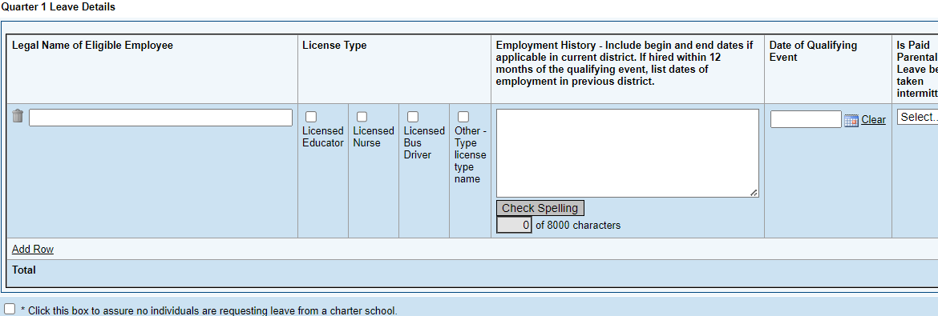

### Related Documents

The **Related Documents** page allows users to upload external related documents. Headers in the Related Documents section indicate if the document is required or optional. If a document is required, ePlan prevents submission of the data and information tool without an upload.

The **Document Template** column provides links to download templates or forms for data and information tool items, if applicable. If **N/A** appears in this column, there is no required template for that specific item. Upload content in any format.

### Checklist

The *Parental Leave Data and Information Tool* includes a **Checklist** section for informational purposes. This section allows the TDOE Parental Leave Consultant to provide feedback to users and communicate corrections that must be made to the data and information tool before it can be approved.

Each section of the checklist is designated with one of these statuses:

* **Not Reviewed:** No review occurred.
* **OK:** The section has no corrections and is approvable.
* **Consultant Reviewed:** The section has been reviewed by the consultant.
* **Attention Needed:** The section has items that need to have corrections completed.
* **Not Applicable:** Checklist item does not apply to the LEA’s submission.

After submission, the department reviews the data and information tool and marks each section appropriately. If the data and information tool contains no items that are marked as **Attention Needed**, the data and information tool is approvable.

If the data and information tool contains items that are marked as **Attention Needed**, the data and information tool will be returned to the user with a status of **Not Approved**. The user must review the checklist for items that are marked **Attention Needed** and make the necessary changes to those items. Only the checked items in the areas marked **Attention Needed** need correction. The user should check for notes and additional comments.

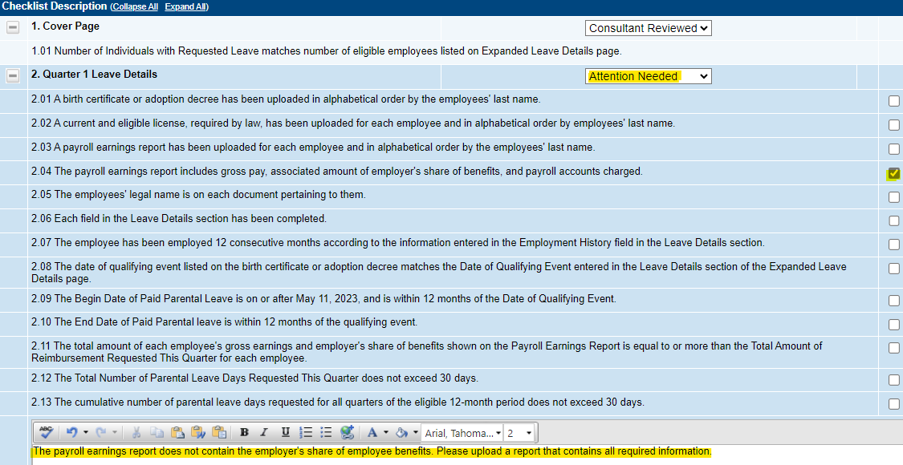

Once the user has made the necessary adjustments, the user resubmits the data and information tool for approval. If the department determines that the area is corrected, **Attention Needed** will be changed to **Consultant Reviewed** by TDOE Parental Leave Consultant. If the items needing attention still have not been corrected, the data and information tool will be returned with a status of **Not Approved**.

## Validations

ePlan runs data and information tool validations as checks to help users complete the data and information tool correctly. Users can view validation messages from the Sections page, by clicking “Messages” in the Validation column. Users can view all validation messages in the data and information tool, or validation messages for the individual section or page.

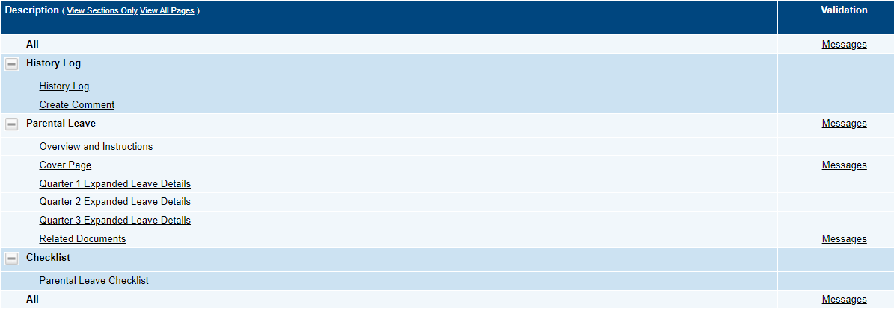

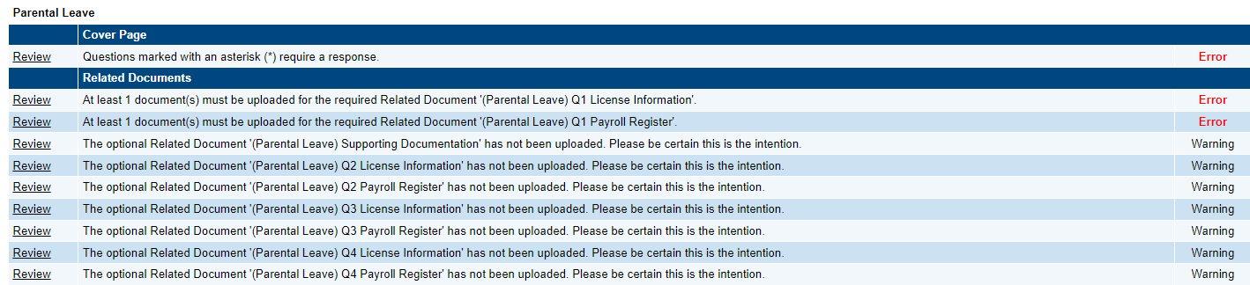

On the **Validation Messages** page, items marked **Warning** are validations that users are not required to address prior to submitting the data and information tool. Examples of warnings are not uploading an optional related document.

Items marked **Error** are incorrect, and users must address each one before submitting the data and information tool. Examples of errors are (1) not checking all confirmation boxes, (2) not completing each required information field, and (3) not uploading a required related document.

* If the user does not address all **Error** validations, ePlan will not allow a user to submit the data and information tool. Click on the *Review* link to go to the identified page to make corrections.

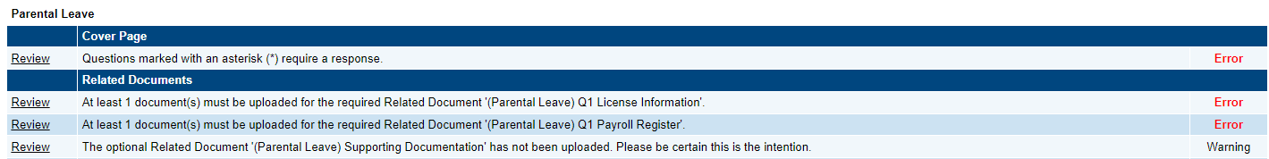

## Submission

When all data and information tool sections and pages are complete and any validation errors are cleared, the data and information tool is ready for submission and the approval process. Refer to the **ePlan User Access** section of this guide or the individual data and information tool guide for the approval workflow.

To submit the data and information tool for review, the user changes the data and information tool status on the **Sections** page to **Draft Complete**. This generates an email to the next user in the approval workflow who must review the draft and click **Approved** (or **Not Approved**) at the top of the **Sections** page.

Once the data and information tool receives approval from the TDOE Parental Leave Program Director, the LEA may expect reimbursement within 30 days.

## How to Print in ePlan

* Users may print or download a PDF from the *Sections* page.
* To print the entire data and information tool, click the ***Print*** link across from the word “*All*” at the top of the *Sections* page. ***NOTE:*** *Print requests do not include any uploaded related documents.*
* To print a single page, click on the ***Print*** link across from the name of the page.
* To print an entire section, click on the ***Print*** link to the far right of the section name. 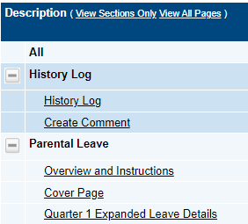 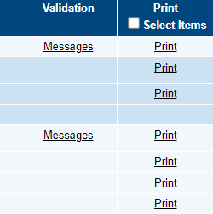
* To choose multiple pages, check the **Print Select Items** box at the top of the print column to select more than one page. The **Print** links appear as checkboxes. Select all text boxes for the desired print request.
* Select the checkboxes and click **Print** at the top of the column.
* The **Print Request** screen pops up. Users may rename their print job here.
* Click **Print**.
* The **Generating Document** screen appears. The system takes 20–30 seconds to generate small print documents. For larger files, expect an email from the ePlan system when the file is ready to download.
* After ePlan generates the print file, click **Return to Funding Applications**.

The PDF generated by ePlan appears at the top of the page from the **TDOE Resources** menu item. The PDF link remains in **TDOE Resources** for five (5) days. Users may use the *“Delete”* links to remove any print jobs.

# Troubleshooting

The following are answers to frequent questions about ePlan application functionality.

## User Access

If an ePlan user is not able to work in an data and information tool, it is usually due to one of these three reasons:

* The user is not using the Google Chrome browser. For best results: always use Google Chrome to access ePlan. ePlan does not have the same functionality in other browsers.
* The tool is not in the right work step or status. Users can only edit a data and information tool when it is in **Draft Started** or **Revision Started** status.
* The user does not have the right role to work on the data and information tool. When hovering the cursor over **Change Status To** options, a tooltip appears that indicates the roles with access to make the status change. This tooltip will list the names of individual users associated with each permitted role. Users can also access the address book to see which roles an ePlan user has.

ePlan’s address book for each organization contains a list of every user that has an ePlan role.

* The LEA Role Contacts list all the roles. If the role is not listed in the address book, no one has been assigned to that role.
* The LEA Funding Application contacts are contacts selected for a funding application.
  + A contact is different from a role. A role assigns access to complete a task in ePlan.
* User Access forms are in ePlan’s TDOE Resources in the User Access Form folder.
  + Users do not need an ePlan role to access TDOE Resources.

See **ePlan User Access** for more information about the ePlan status workflow and user roles.

## Validation Messages

* This feature shows any errors that will prevent an application from moving forward.
* Click the messages under Validation on the Sections page to see any errors or warnings.



## Post-Submission

When users need to revise a data and information tool after changing the status to **Draft Completed** prior to the submission deadline, contact the next approver in the workflow and ask that they change the status to **Not Approved** to return the application access to the previous user in the workflow. If the tool has proceeded through the workflow to the TDOE Parental Leave Consultant, users can contact the consultant or ePlan Help to request that the tool be returned to the previous step in the workflow.

## Inbox

Several ePlan functions automatically generate emails which the system sends to users. The **Create Comment** function prompts ePlan to send an email message to the selected recipients. Additionally, **System Notifications** are sent to users because of a **Status Change** to support **Workflows**.

All email messages sent or received by a user through ePlan can be accessed from the **Inbox**. The **Inbox** section of ePlan contains the **Email Message Archive** and **Items Awaiting Approval**. The **Email Message Archive** will contain all emails sent to or received from another ePlan user through the system. Users may select the time period to display. Messages received by the user will appear first; scroll down to the lower half of the page to view sent messages. Comments with email notifications can be accessed from the **Inbox** in addition to the **History Log** section of the data and information tool.

When a **System Notification** is generated related to a **Status Change** that requires the user to complete an approval step, users will find these in **Items Awaiting Approval**.