**Single Sign On (SSO) Recommendations**

**Slowdowns**

Below are some suggestions on how to deal with a slow response time when logging into your SSO account.

The best practice is to log out of your SSO account every time you are done. If you do not see the message shown below, which may take a few minutes to appear, then your account may get stuck in a loop the next time you try to access your SSO account because it never logged out.

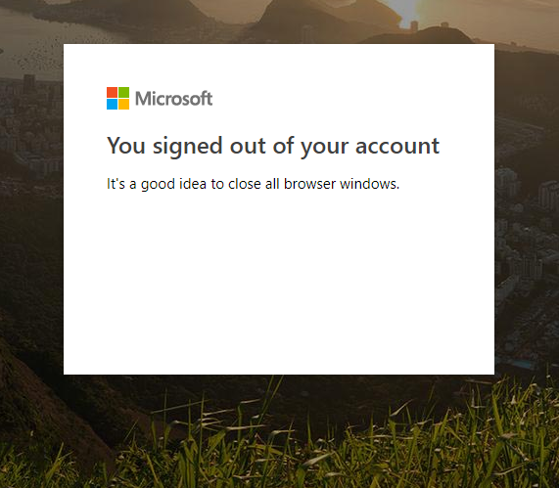

If you do not log out of your account, please clear your cache and open a new browser to log back in.

Here are some other options for different browsers that may work when users are experiencing SSO issues.

**Chrome:**

1. Start Chrome and click the three dots icon in the top right corner of the screen to select an incognito window.
2. Click New Incognito Window and login again.

**Firefox:**

1. Open private browsing in Firefox.
2. To enable private browsing in Firefox, click on the hamburger icon at the top right and then select New Private Window.

**Safari:**

1. Navigate to the top menu.
2. Go to File > New Private Window from the menu bar.
3. A new blank Safari window will open.
4. Now, if you open other tabs, they should also appear in private mode.

**Timeout InformTN**

The following message can occur when there is a SSO outage. This specific message happens when a user opens the new planning tool or InformTN. It is recommended in these instances to log back out and log in again to check if the outage has cleared.

