**FY25 Significant Disproportionality Instructions**

Any district user with a district role can upload or download to the LEA Document Library.

* 1. If a user needs a district role, they can find the user access folder by clicking on TDOE Resources on ePlan’s home page, eplan.tn.gov.
  2. This home page can access the TDOE Resources without an ePlan login.
  3. Here is a screenshot of the form, showing a common role of LEA Data View, which allows a user to upload and download from ePlan’s LEA Document Library.
  4. **ePlan’s address book includes a list of all the users with LEA roles.**

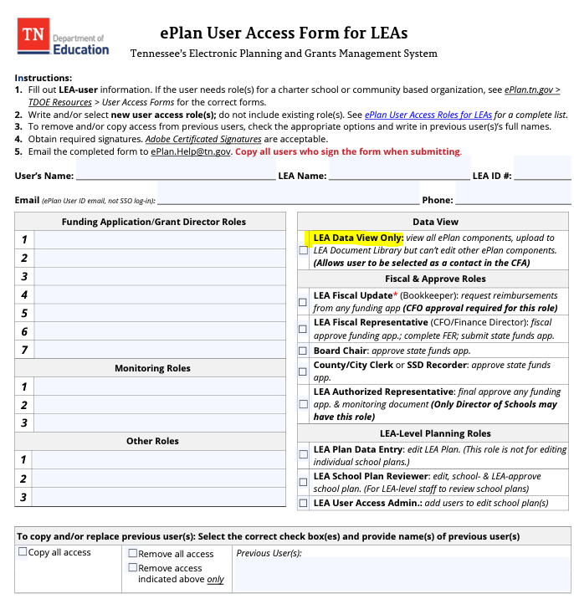

1. Select the **LEA Document Library** from the main menu.

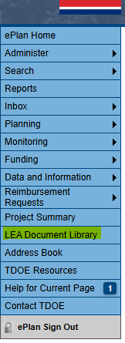

1. To open the 2025 LEA Document Library, click on 2025. Then click the + in front of the 2025 as shown below.

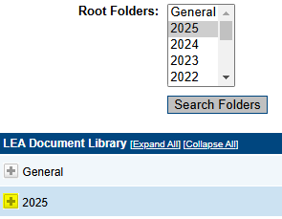

1. Click the + to open the Significant Disproportionality folder.

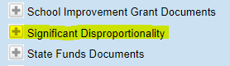

1. There are 3 folders that contain the **Determination Letter, Data Files and Appeals.**

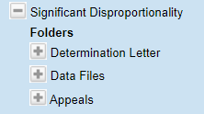

1. Click the + to view the documents that have been uploaded.

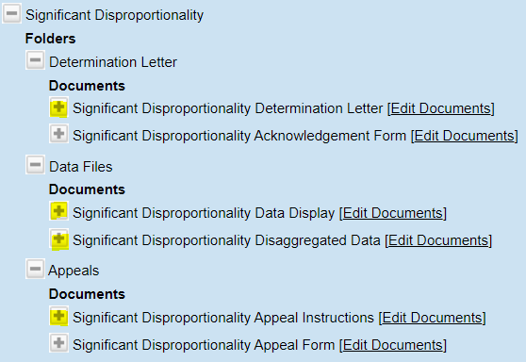

1. Click on the **Edit Documents** to download or upload documents.

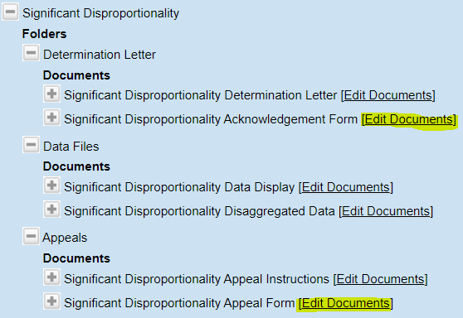

1. Templates can be downloaded after clicking on the **Document Template** as shown below.

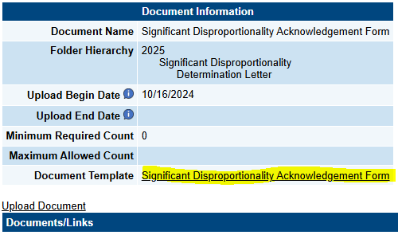

1. To upload a document, click on the **Upload Document** as shown below.

