**Steps to Clear Cache for Google Chrome**

1. Open your settings by clicking the 3 dots in the upper right hand corner of your Google Chrome Browser window.

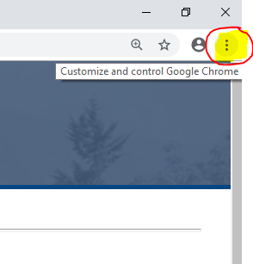

1. Click the settings as highlighted below.

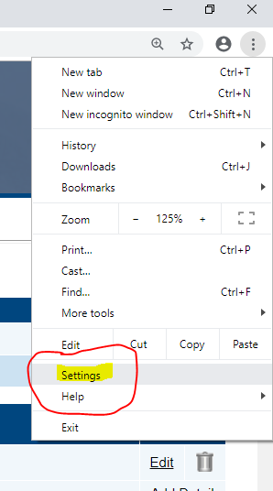

1. Scroll to the bottom to find the Advanced as highlighted below.

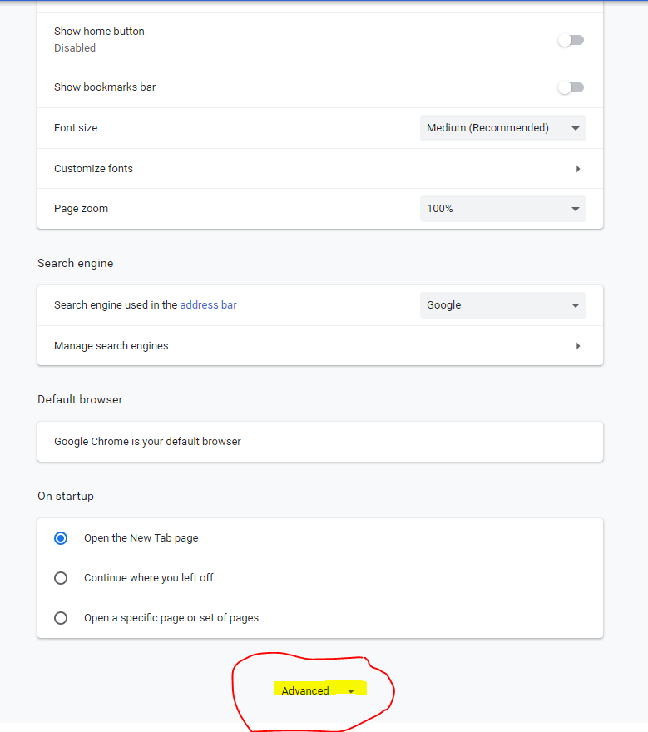

1. Click the right arrow to open the clear browsing data.

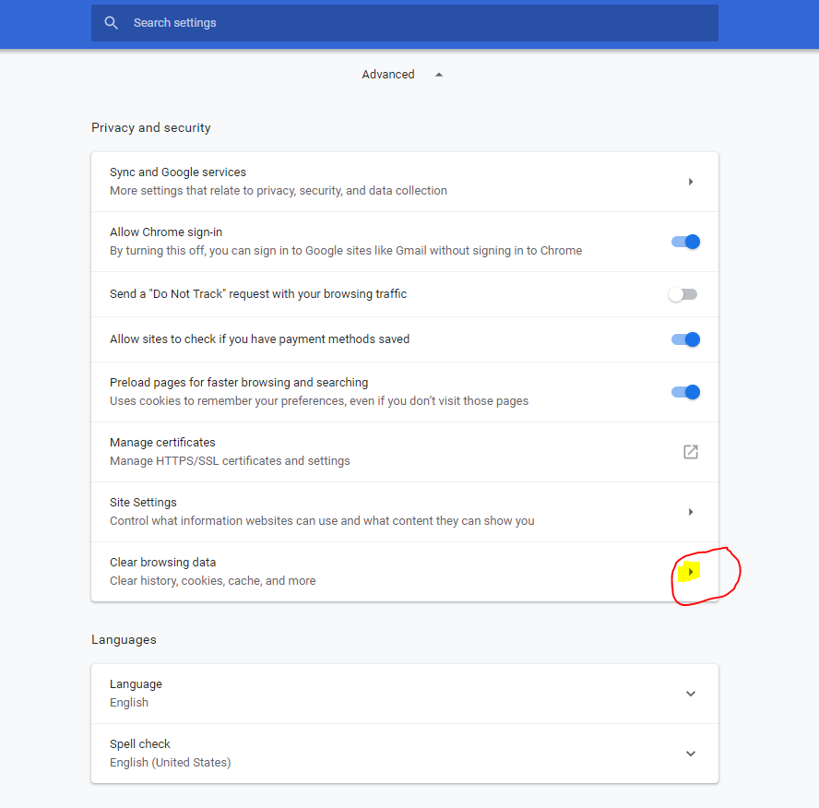

1. Ensure the following checkmarks are selected and click the clear data as highlighted below.

