**2025 Teacher Bonus Resolution**

**Screenshot Instructions**

1. Any district user with an LEA role can upload or download to the LEA Document Library.
   1. The [LEA User Access Form](https://eplan.tn.gov/DocumentLibrary/ViewDocument.aspx?DocumentKey=1511231&inline=true) features roles that permit users to access the LEA Document Library.
   2. Below is a screenshot of the form that shows the common **LEA Data View** role, which allows users to upload and download from ePlan’s LEA Document Library.
   3. School planning roles do not permit users to access the LEA Document Library.

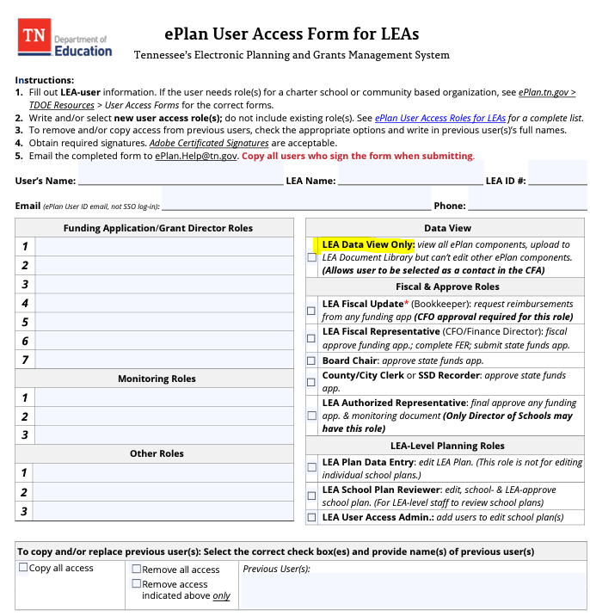

1. Select the **LEA Document Library** from the main menu.

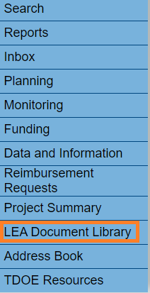

1. To open the 2025 LEA Document Library, click **2025** and then click **Show Folders**. Next, click the **+ icon** in front of **2025** as shown below.

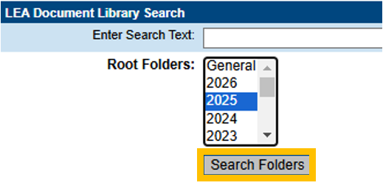

1. Scroll down the list to click the **+ icon** to open the 2025 Teacher Bonus Resolution folder.

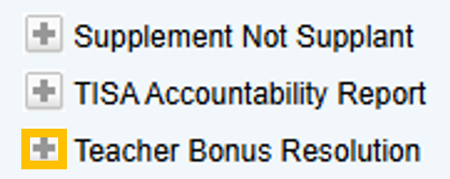

1. There is 1 Teacher Bonus Resolution Approved document here:

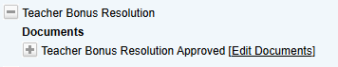

1. Click on the Edit Documents to upload the document.

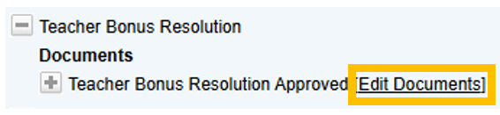

1. Click **Upload Document** to upload the document.

