Converting a Text File produced by Local Government Software to an Excel File for Upload into Eplan

1. Locate the **sde.txt** file that you created from either Flexgen, Nextgen, or other accounting software . This file may reside on your server or perhaps you can access it from your desktop. Generally the file is located in L:\files and is named **sde.txt**. In the example below, the **sde.txt** file is located in L:\gpfiles. The file location of **sde.txt** will be unique to your school district. Also, look under the date modified column to the right of the file name to ensure that the file was recently created. The **sde.txt** file below was created on 4/7/2015.

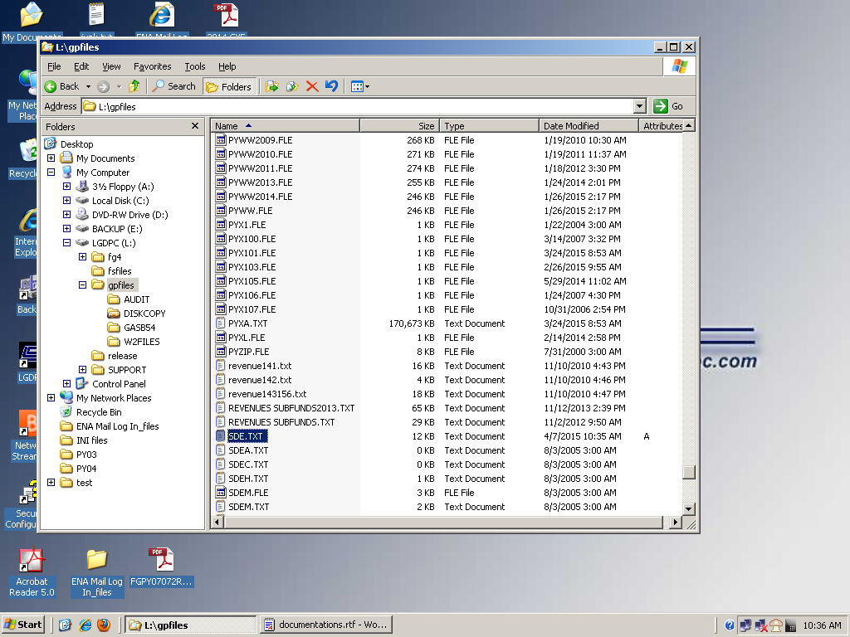

1. Email or transfer the **sde.txt** file to your desktop. Right click on the file and open the file with Notepad.

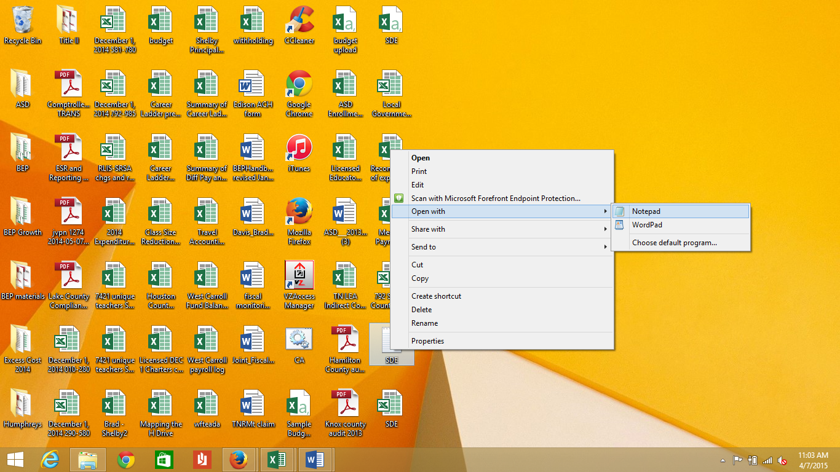

1. The file should look similar to the one below. Make sure it contains Column headings in the first row. If it does not contain Column Headings, contact Local Government or your software vendor. 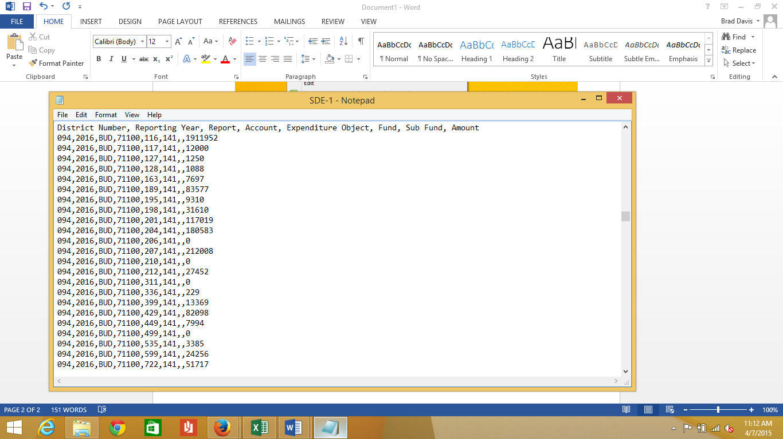
2. Click File save as.

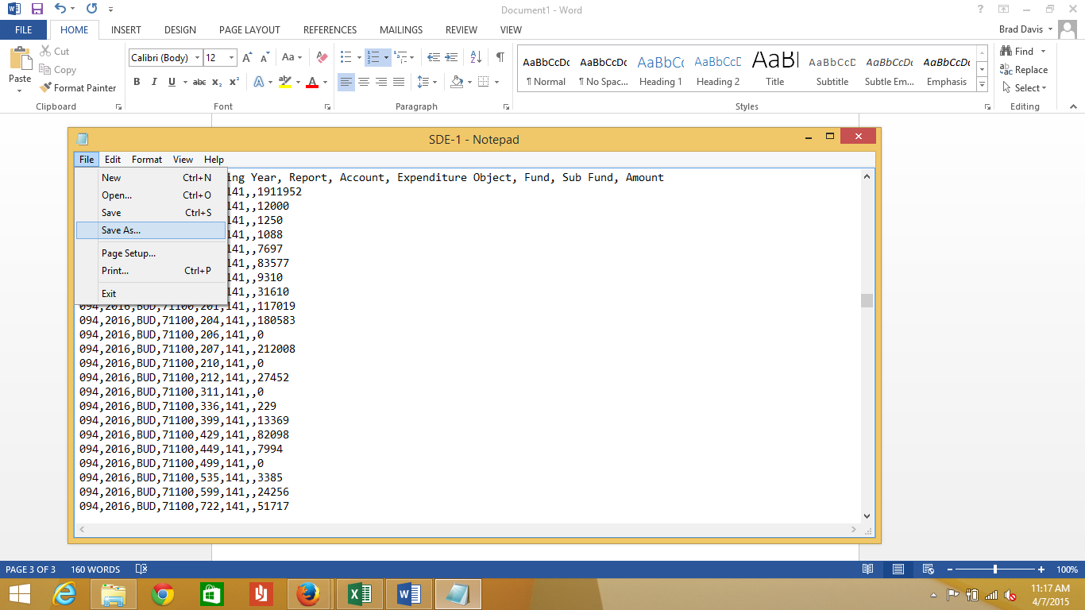

1. The file must first be saved as a csv file to enable conversion to an Excel file. Thus, in the file name text box, change the file name to **sde.csv** You can save this file onto your Desktop for easy access. When finished click the **Save** button.

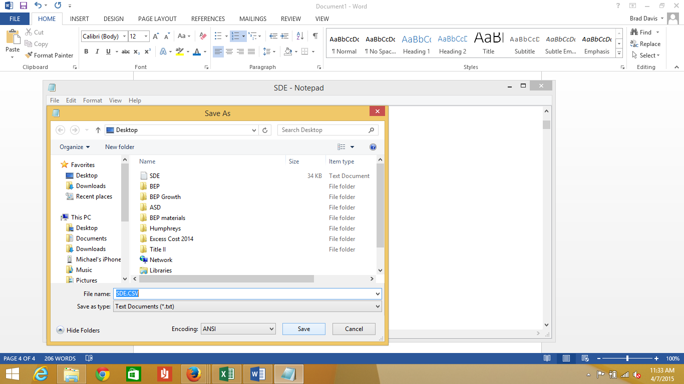

1. Locate the **sde.csv** on your desktop. Double-click to open.

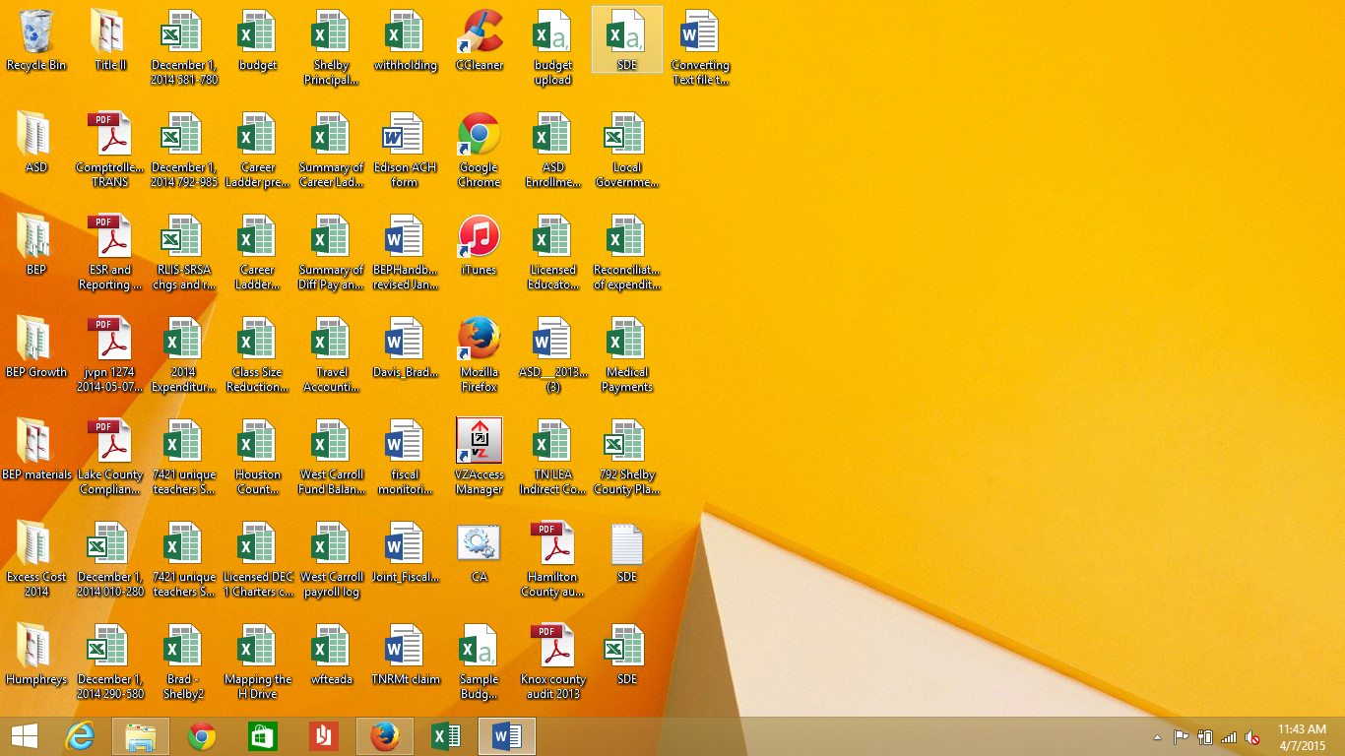

1. The file will now open in Excel and should look similar to the file below.

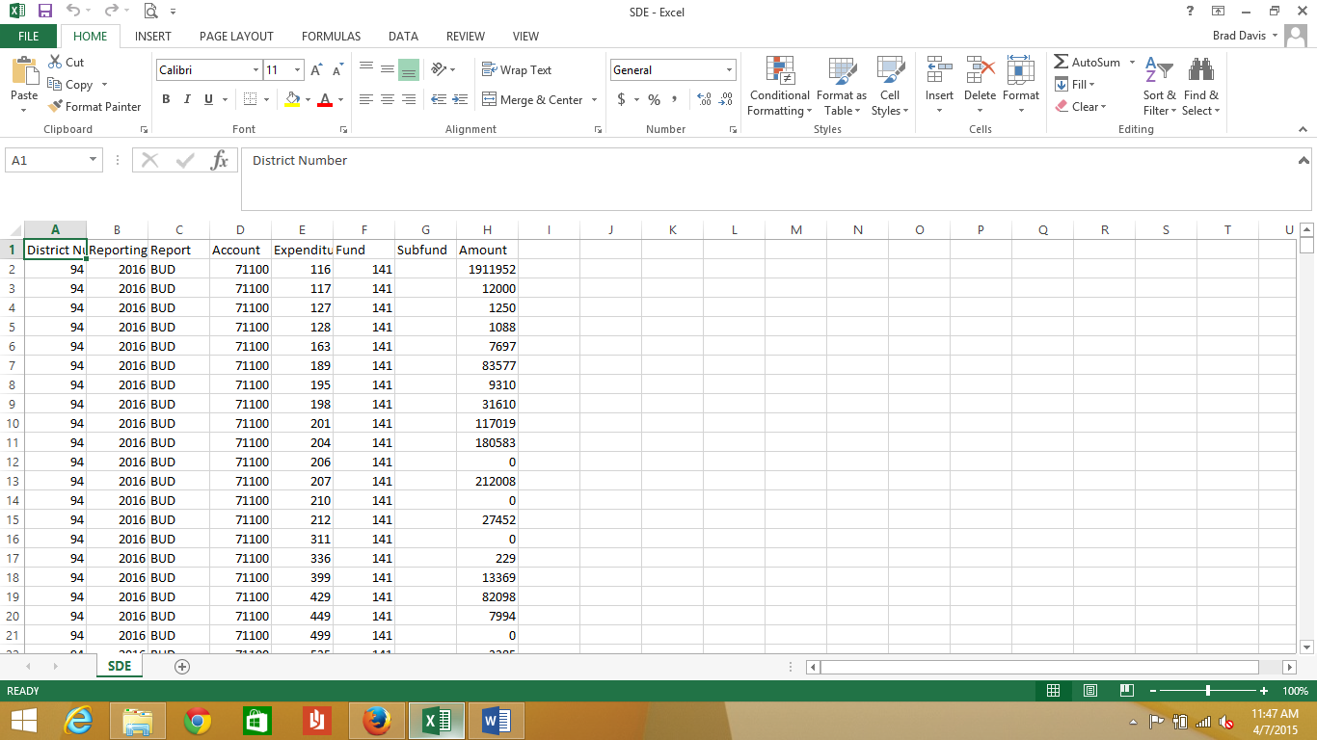

1. Click on **File Save As**. Expand the **Save As Type** dropdown.

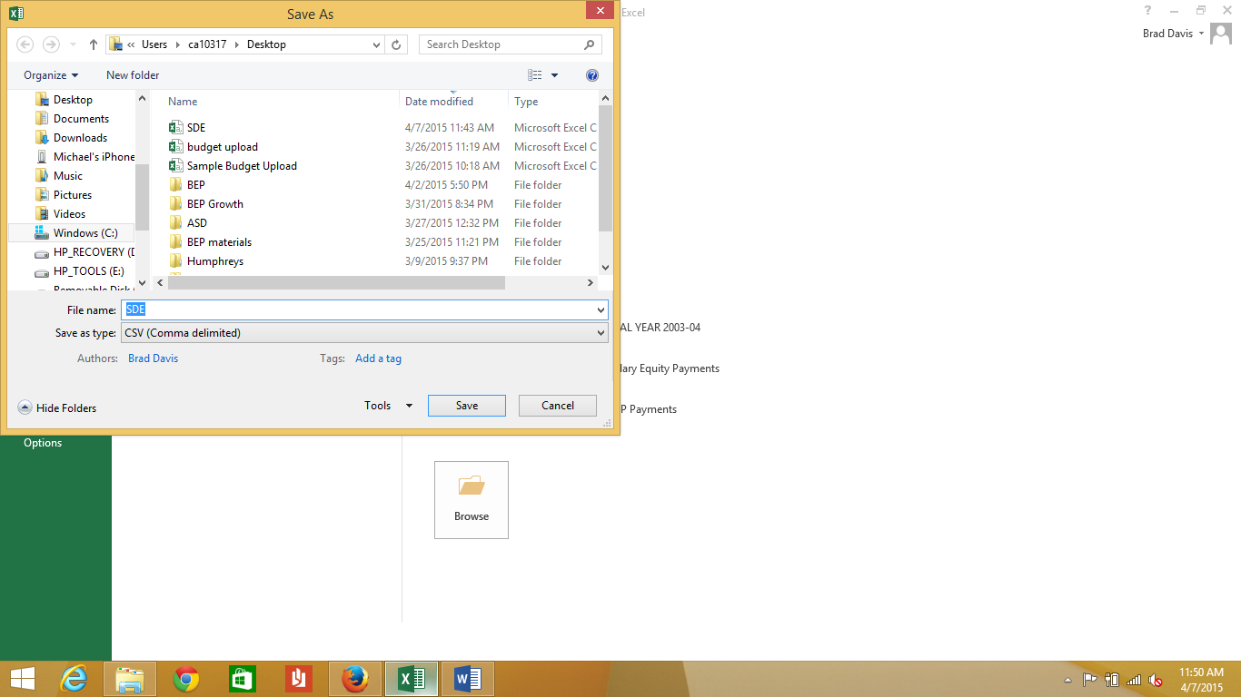

1. Choose **Excel Workbook** from the dropdown. Click **Save**.

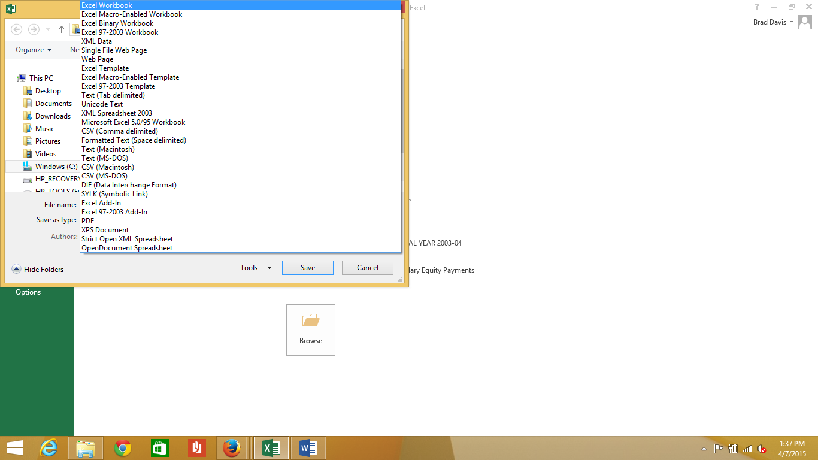

1. The file should now be named **sde.xlsx**

Budgeted expenditures and revenues must be uploaded separately within Eplan. In addition, funds including 141, 143, 144, 156, and 177 must be uploaded separately from each other. If you have created a file that contains both the revenues and expenditures for all your funds with the exception of fund 142, then you can use the file converted in steps 1-10 of this guide to upload budgeted revenues and expenditures within the various state funds within Eplan. You would use this .xlsx file multiple times to upload within the applicable state fund section and including the revenue section and budget section within each state fund.

In conclusion, if initially you create a text file including the budget for all funds you use, you would need only convert this file to .xlsx format and then use this file multiple times within Eplan to upload your budget for all state funds