 **Local Education Agency (LEA) User Access Agreement TN PULSE**

The Family Educational Rights and Privacy Act (FERPA) (20 U.S.C. § 1232g; 34 CFR Part 99) is a Federal law that protects the privacy of student education records.  FERPA allows local education agencies (LEAs) to disclose to contractors without parental consent personally identifiable information from an education record of a student, only when the contractor meets the requirements of 34 C.F.R. 99.31(a)(1)(i). The contractor must: 1) perform a service or function for which the LEA would otherwise use employees; 2) be under the direct control of the LEA with respect to the use and maintenance of educational records; and 3) be subject to the requirements of 34 C.F.R. 99.33(a) governing the use and redisclosure of personally identifiable information from education records. The LEA is responsible for managing TN PULSE User Types to grant access in accordance with state and federal confidentiality laws. No contractor or third party shall have access unless the LEA has established them as an authorized representative under FERPA and ensures that contractor access is limited to only those student records and system functions needed to complete duties as an authorized representative.

Additionally, the Individuals with Disabilities Education Act (IDEA) regulations at 34 C.F.R. 300.623 require:

1. Protection of the confidentiality of personally identifiable information at collection, storage, disclosure, and destruction stages;
2. Designation of one official to assume responsibility for ensuring the confidentiality of personally identifiable information;
3. All persons collecting or using personally identifiable information receive training or instruction regarding the state's policies and procedures under 34 C.F.R. 300.123 and 34 CFR part 99; and
4. Maintenance, for public inspection, of a current listing of the names and positions of employees and contractors who may have access to personally identifiable information.

An annual user access agreement must be provided to the Tennessee Department of Education (TDOE) in which the LEA agrees to adhere to all state and federal laws, including the confidentiality provisions of IDEA and FERPA, when using TN PULSE. The *TN PULSE LEA User Access Agreement* **opened in ePlan on August 1 and must be completed no later than October 1.**

Failure to comply with this access agreement may result in loss of access to TDOE data and/or data systems, or other appropriate action. The LEA is responsible for informing its employees and contractors of the potential repercussions of failure to comply.

# TN PULSE LEA User Access Agreement Process

1. 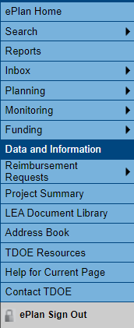To navigate to applications from the ePlan homepage, click the **Data and Information** tab on the left menu bar.
2. Select the desired fiscal year from the dropdown. Data and information tools are stored in ePlan according to the state fiscal year (i.e., 2025 indicates the 2024–25 school year).



1. Click on the TN PULSE LEA User Access Agreement to access the tool.

1. Click ***Draft Started.*** (If you are unable to click ***Draft Started***, hover over the ***Draft Started*** button to see a list of individuals who have access. If a specific user needs access to the ***LEA TN PULSE User Access Agreement Director*** role, they must complete the [LEA User Access Form](https://eplan.tn.gov/DocumentLibrary/ViewDocument.aspx?DocumentKey=1511231&inline=true) and submit it to ePlan.Help@tn.gov.)

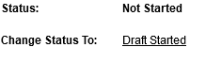

1. Click ***Confirm*** to change thestatus to ***Draft Started.***

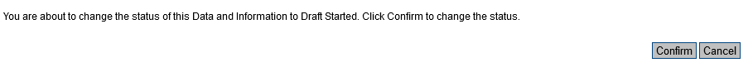

1. Select the ***Cover Page***. For each title listed, the respective individual must log into ePlan and complete the items with an asterisk. For those LEAs in which the Special Education Director also serves as the TN PULSE Site Administrator, the Special Education Director will complete both titles.
2. Select the ***TN PULSE LEA User Access Agreement*** and click the appropriate response.



1. Once both sections are completed, the Special Education Director will then go back to the **Sections** page and click on ***Draft Completed***.

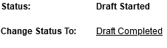

1. Check the box to attest that the information provided is accurate to the best of your knowledge.
2. Click ***Confirm*** to change the status to ***Draft Completed.*** The ***Cover Page*** and the ***TN PULSE LEA User Access Agreement*** sections must both be completed before the status can be changed to Draft Completed.



1. The Director of Schools (LEA Authorized Representative) then must change the status to ***LEA Authorized Representative Approved.***

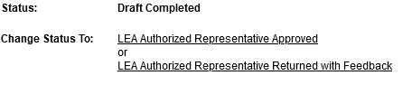

1. *Click Confirm to change the status to* ***LEA Authorized Representative Approved.***

