­



ePlan General Technical Application Guide

**GEER Non-Public Schools Grant**

Tennessee Department of Education | April 2023

**Adam W. Holdren**

Director of Choice Grants

EANS.Grant@tn.gov

Contents

Introduction 3

ePlan User Access 3

Workflows 3

ePlan Data and Information Tool 5

Accessing the Data and Information Tool 5

Saving Data and Information Pages 6

Data and information tool Sections and Pages 7

Change Log 7

History Log and Create Comment 8

Cover Page 9

Program Details 10

Contracted Services Information 10

Program Assurances 11

Related Documents 11

Validations 12

Submission 13

How to Print in ePlan 13

Troubleshooting 14

User Access 14

Validation Messages 15

Post-Submission 15

Inbox 15

# Introduction

(Insert Introduction about Purpose of Data and Information tool here)

The (Insert Name) Data and Information tool can be accessed through the Tennessee Department of Education’s eGrants platform, [ePlan.tn.gov](https://eplan.tn.gov/).

# ePlan User Access

All users must have the correct ePlan user access role to access and complete the Data and Information tool. Users with existing ePlan access can verify current user access roles in the Address Book. To view existing access, visit **ePlan.tn.gov**, navigate to the **Address Book** and **LEA Role**.

New ePlan users and existing ePlan users who need to request a User Access role must request the additional role using the appropriate **ePlan User Access Form**. Access the form by navigating to eplan.tn.gov > TDOE Resources > 1. User Access Forms and select the correct form according to organization type, or click on the links below:

* [**ePlan User Access Form for a Single Non-Public School**](https://stateoftennessee.formstack.com/forms/eplan_user_access_form_for_non_public_schools)

Users do not need to log in to ePlan to access *TDOE Resources* in ePlan. Follow the instructions on the *User Access Form*, then email the completed form to [**ePlan.Help@tn.gov**](mailto:ePlan.help@tn.gov) to request additional access roles. User access requests may take up to two business days to process. Users will receive an email reply when access has been granted.

## Workflows

Below are the roles and the order of the workflow steps for the data and information process. These roles and the workflow may vary slightly for specific programs.

| ePlan Role | ePlan Function |
| --- | --- |
| ***Non-Public GEER Grant Director*** | Click ***Draft Started*** (or ***Revision Started*** for revisions)  Respond to questions, upload files, etc |
| ***Non-Public GEER Grant Director*** | Click ***Draft Completed*** (or ***Revision Completed*** for revisions) |
| ***LEA Authorized Representative***  (Director of Schools) | Click ***LEA Authorized Representative Approved***  (or ***LEA Authorized Representative Not Approved***) |
| ***TDOE Program Director***   (Department project directors) | Click ***TDOE Program Director Approved*** (or ***TDOE Program Director Returned Not Approved***) |

After each status change, ePlan automatically sends a notification email to all users in the LEA who have the ePlan role of the next step in the process. Reimbursements cannot be submitted until approval is received from the TDOE Program Director.

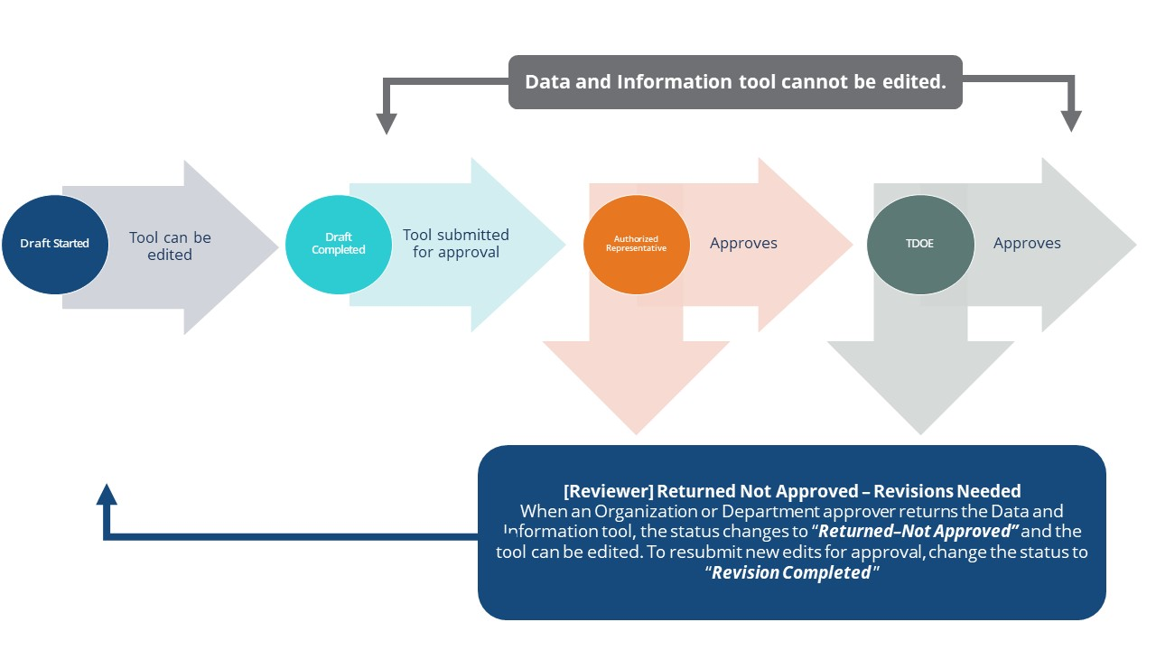

# ePlan Data and Information Tool

## Accessing the Data and Information Tool

To navigate to applications from the ePlan homepage, click the **Data and Information** tab on the left menu bar. ***NOTE:*** For users with ePlan roles for multiple organizations, return to ePlan home to select the correct organization before proceeding to Data and Information.

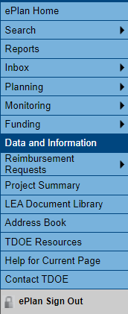

Select the desired fiscal year from the dropdown in the upper left corner of the screen. Data and information tools are stored in ePlan according to the state fiscal year (i.e., 2022 indicates the 2021–22 school year). Click on **the Data and Information tool name** to access the tool.

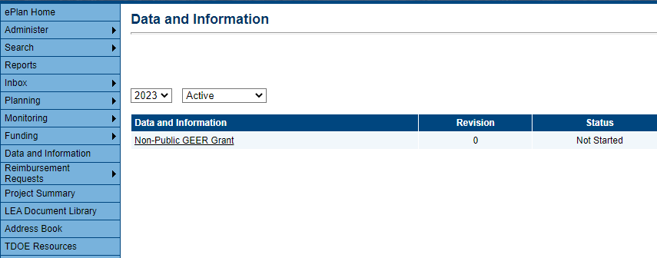

The data and information tool loads to the Sections page. To begin the tool, next to **Change Status To:** click on ***Draft Started***.

**NOTE:** Once a draft has been started, users may wish to access previous versions. To access previous versions, return to **Data and Information** and select the appropriate prior year.

## Saving Data and Information Pages

After working in a Data and Information Tool, users must click the “Save and Go To” button, then ensure that the page has finished saving before closing ePlan or leaving the page.

Users can tell that the page has not saved when the browsers spinning wheel or loading icon is still occurring. The screenshot below shows an example of a page that has not finished saving. Please make sure that the browser’s loading icon is no longer spinning before closing the page

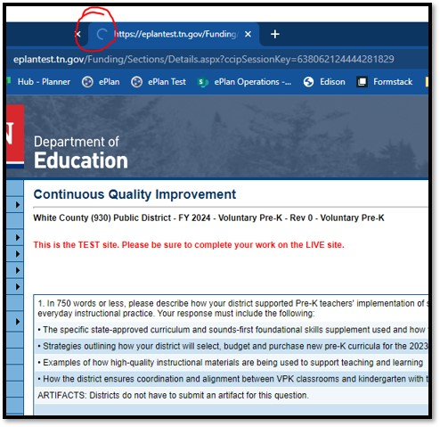

The best way to see if a change to the tool was saved after leaving the page is to review the change log. The change log for the Data and Information tool can be accessed from the Sections Page.

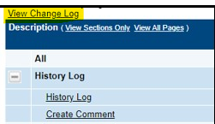

## Data and information tool Sections and Pages

The **Sections** page lists all the available sections and pages within an data and information tool such as: ***Change Log***, ***History Log****,* ***Create Comment****,* ***Cover Page****,* ***Program Details****,* ***Assurances****,* ***Related Documents****, and* ***Checklist***. The **Sections** page is helpful in navigating to the specific sections and pages which must be completed.

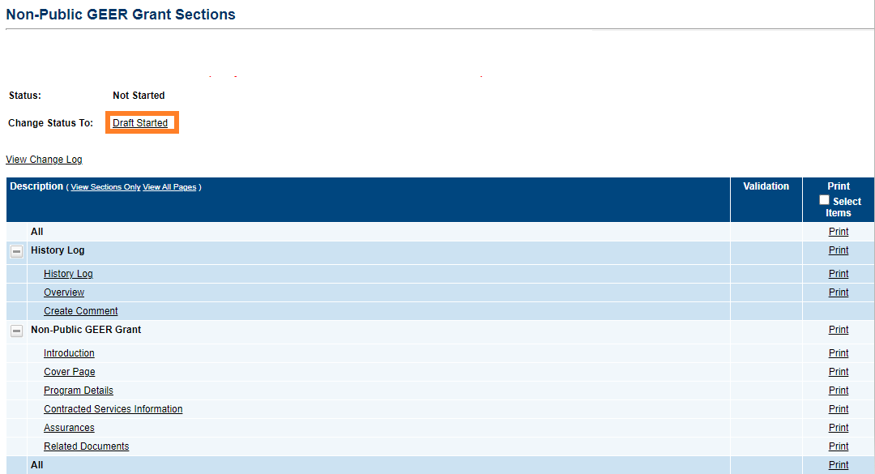

After clicking on a page, hover over the **Save And Go To** button and click on **Sections** to return to the *Sections* page.

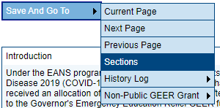

### Change Log

The **Change Log** may be accessed on the main sections page for every data and information tool. It lists every change or update since the previous status. This helps users identify changes that have been made to the data and information tool since they last viewed it. More information about the **Change Log** is available in the ePlan User Manual.

### History Log and Create Comment

The **History Log** contains a record of status changes and comments made on the data and information tool. ePlan users may want or need to create a comment in an ePlan funding data and information tool for one of the following reasons:

* To provide an explanation as a part of the data and information tool’s history.
* To provide information that a user cannot add into the main data and information tool due to the data and information tool’s current status (users can only edit data and information tools that are in a *Draft Started* or *Revision Started* status.)

ePlan creates a running record of all comments. Any comment created and saved in an ePlan data and information tool will always be available as a part of the data and information tool’s history log.

#### To Add a Comment in a Data and information tool:

1. Navigate to the data and information tool’s main **Sections** page.

* To navigate to the main data and information tool page from other pages in the data and information tool, click **Go To** and **Sections** as shown and highlighted below.

1. Select **Create Comment** from under the *History Log* on the main section page as highlighted in the screenshot below to navigate to the *Create Comment* page.
2. On the **Create Comment**page, type your comment in the box.
3. If desired, a hyperlink can be inserted in a comment by clicking the hyperlink icon.
4. To send an email notification of this comment to recipients check the box next to **Send Email to ePlan Contacts** below the main comment box.

* Sending an email notification is not required to create the comment.
* If no email notification is needed, click **Save and Go To** to exit the page. The comment is now a part of the Data and information tool **History Log** for everyone to view.

1. **To send an email notification:** Select the recipients to receive notification of the comment from the lists provided and then click **Add**.

|  |  |
| --- | --- |
| **Available Contact Groups** | |
| **LEA Contacts by** **Funding Application** | Available if a contact is selected on the applications contact page. Not all funding applications have contacts on the contact page. |
| **LEA Contacts by Role** | Current users with the applicable role |
| **Other LEA Contacts** | Additional contacts for an LEA |
| **TDOE Contacts** | State users that can complete various ePlan functions. |
| **TDOE Miscellaneous  Contacts** | Lists every State ePlan User by name |
| **Additional Recipients** | Allows you to type in any additional email addresses manually |

* It is a good practice to send a copy of your comment to yourself to let you know when the message has been delivered.

1. The **Recipient Summary** shows who will receive the email.
2. Clicking **Save And Go To** will send the comment notification.
3. Comments with email notifications can be accessed from the **Inbox** on your ePlan tab in addition to the history log of the data and information tool. Additional information about Inbox functionality in ePlan is available in Troubleshooting, **Inbox**.

### Cover Page

The *Cover Page* typically requires entry of general organization information: the ID Number, Organization Name, Official Address, and name and email and phone contact information for organization and program points of contact. Once all fields are complete, hover over the **Save And Go To** button and click on **Sections** to return to the *Sections* page.

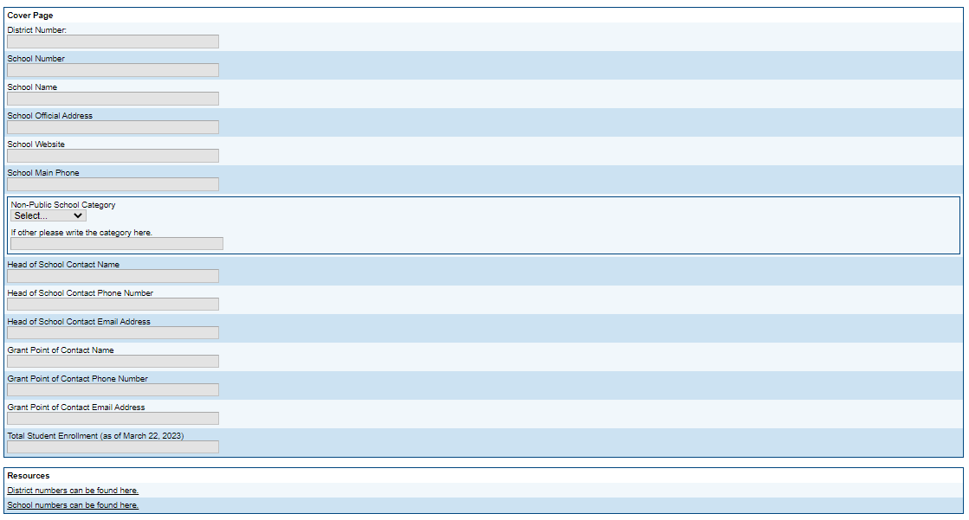

### Program Details

*Program Details* pages include questions specific to the data and information tool. Questions may require numeric or narrative responses or require selection from drop down or checkbox options.

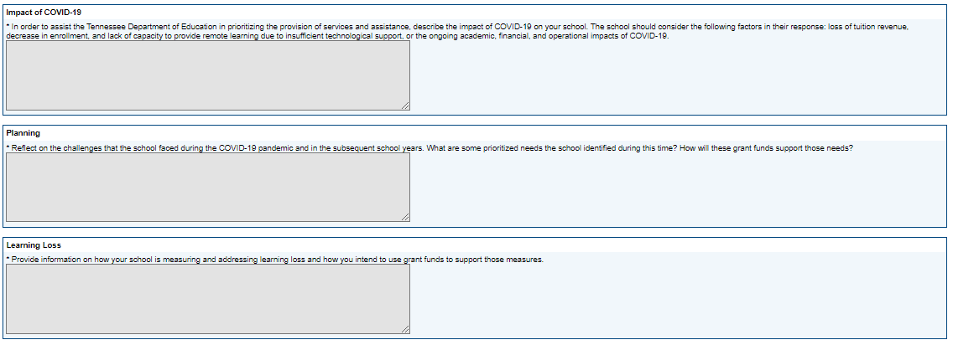

### Contracted Services Information

The Contracted Services page is where you will gather the bulk of the information for your application and provides instructions for how to do so.

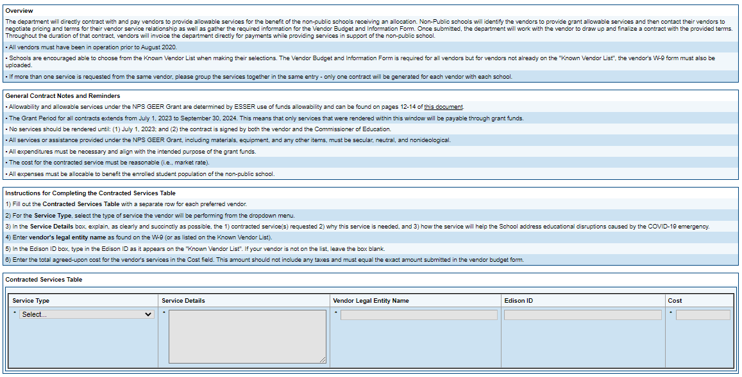

What’s most important on this page is that you complete one row in the Contracted Services table for each vendor that you intend to use with your grant funds. The columns should be filled out with the following information:

* **Service Type** – Select from the drop-down which service type best represents the service
* **Service Details** – Provide a justification for the service that addresses the following two things:
  1. How does the expenditure lead to the intention of the grant? *“To prevent, prepare for, or respond to the COVID-19 pandemic, including its impact on the social, emotional, mental health, and academic needs of students."*
  2. How does the expenditure fit within one of the allowability categories on page 12-14 on the [allowability document](https://urldefense.com/v3/__https:/oese.ed.gov/files/2022/12/ESSER-and-GEER-Use-of-Funds-FAQs-December-7-2022-Update-1.pdf__;!!PRtDf9A!vaGLP-2APVl7jbkLCI_l4LYlIJd95ELiFj7HX47O4eMuZRN71hl7YaABMfNDQnyprm_LZKTiBJ2ZMzw-XQ$)?

**Example of acceptable responses:**

* + - *A&H Air Conditioning will be replacing all 24 HVAC units throughout the building.  The new units have HEPA filters that will improve the indoor air quality (Allowability #18) and therefore decrease the spread of COVID-19 in our building.*
    - *Dragstar Communications will be installing security cameras throughout the building.  These cameras will allow us to reduce risk of virus transmission (Allowability #17) by providing us with a means to monitor contact tracing throughout the building.*
* **Vendor Legal Entity Name** – this should match the name on their W-9
* **Edison ID** – This is the ID provided by the state. Only known or repeated state vendors will have this. If the vendor does not have one, leave this blank.
* **Cost** – This is the entire cost of the project for that vendor. The cost should be represented in whole dollars (no cents) and is a fixed cost that will be used to finalize the contract.

### Program Assurances

Users must review all program assurances thoroughly. All items specified are requirements of the program, legislation, or regulation. Program Assurances are built into the ePlan data and information tool on Program Details pages, or on individual Program Assurances pages. By checking the assurance check box, the user affirms that they have read and understand all requirements and that the user assures the state education agency that the user meets each of the conditions detailed in the Assurances.

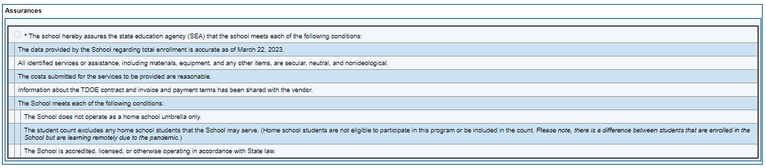

### Related Documents

The **Related Documents** page allows users to upload external related documents. Headers in the Related Documents section indicate if the document is required or optional. If a document is required, ePlan prevents submission of the data and information tool without an upload.

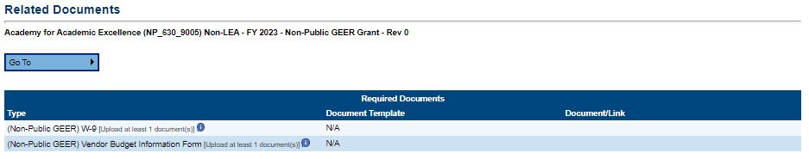

The **Document/Link** column is where you will upload documents for data and information tool items. The following documents should be required for each vendor:

* **Vendor Budget Information Form** – should be completed and signed for each vendor. Upload file (preferably as a PDF) and save it as **“VBF – *Vendor Name*”**
* **W-9 Form** *–* Required for vendors not on the Known Vendor list. Should be signed (with ink, not digital signature) and contain a data within the last year. Upload file (preferably as a PDF) and save it as **“W9 – Vendor Name”**

To upload your files, click the **Upload New** link to begin the upload.

Click the **Choose File** button to browse for the document.

**Upload** the document and enter a specific name for the document.

Click **Create** to upload the document.

## Validations

ePlan runs data and information tool validations as checks to help users complete the data and information tool correctly. Users can view validation messages from the Sections page, by clicking “Messages” in the Validation column. Users can view all validation messages in the data and information tool, or validation messages for the individual section or page.

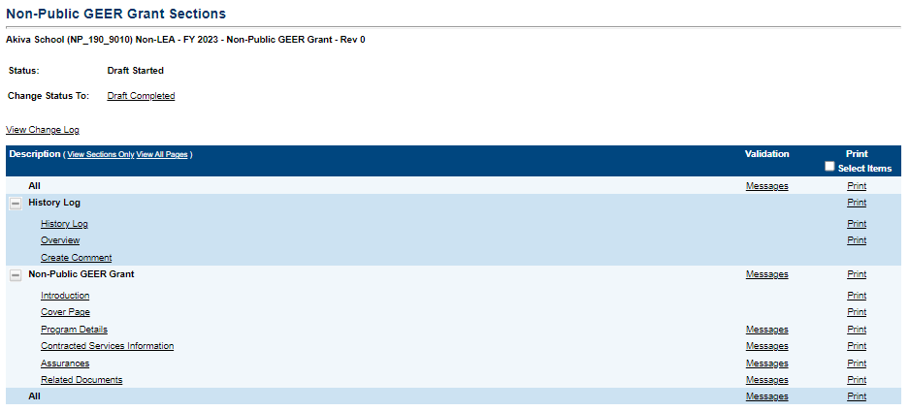

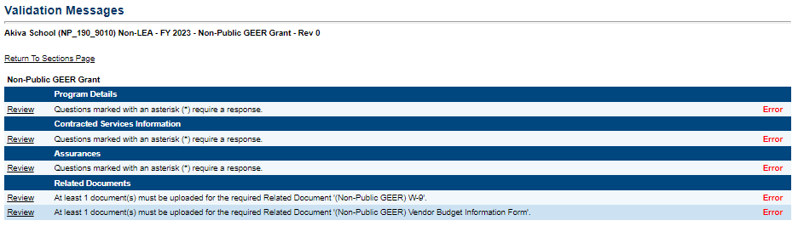

On the Validation Messages page, items marked **Warning** are validations that users are not required to address prior to submitting the data and information tool. Examples of warnings are not uploading an optional related document or budgeting an entire allocation.

Items marked **Error** are incorrect, and users must address each one before submitting the data and information tool. Examples of errors are (1) budgeting for more than the allocation, (2) budgeting more indirect cost than is allowable, (3) not budgeting in a section where there is an allocation, (4) not uploading a required related document, and (5) not responding to a required question.

* If the user does not address all **Error** validations, ePlan will not allow a user to submit the data and information tool. Click on the *Review* link to go to the identified page to make corrections.

## Submission

When all data and information tool sections and pages are complete and any validation errors are cleared, the data and information tool is ready for submission and the approval process. Refer to the **ePlan User Access** section of this guide or the individual data and information tool guide for the approval workflow.

To submit the data and information tool for review, the user changes the data and information tool status on the **Sections** page to **Draft Complete**. This generates an email to the next user in the approval workflow who must review the draft and click **Approved** (or **Not Approved**) at the top of the **Sections** page.

Once the data and information tool receives approval from the TDOE Program Director, users may begin [**submitting reimbursements**](https://eplan.tn.gov/DocumentLibrary/ViewDocument.aspx?DocumentKey=1813913&inline=true)

## How to Print in ePlan

Users may print or download a PDF from the *Sections* page.

* To print the entire data and information tool, click the ***Print*** link across from the word “*All*” at the top of the *Sections* page. ***NOTE:*** *Print requests do not include any uploaded related documents.*
* To print a single page, click on the ***Print*** link across from the name of the page.
* To print an entire section, click on the ***Print*** link to the far right of the section name. In the example shown, the user is printing the entire ***ESEA Requirements*** section.
* To choose multiple pages, check the ***Print Select Items*** box at the top of the print column to select more than one page. The ***Print*** links appear as checkboxes. Select all text boxes for the desired print request.
* Select the checkboxes and click ***Print*** at the top of the column.
* The ***Print Request*** screen pops up. Users may rename their print job here.
* Click ***Print***.
* The ***Generating Document*** screen appears. The system takes 20–30 seconds to generate small print documents. For larger files, expect an email from the ePlan system when the file is ready to download. 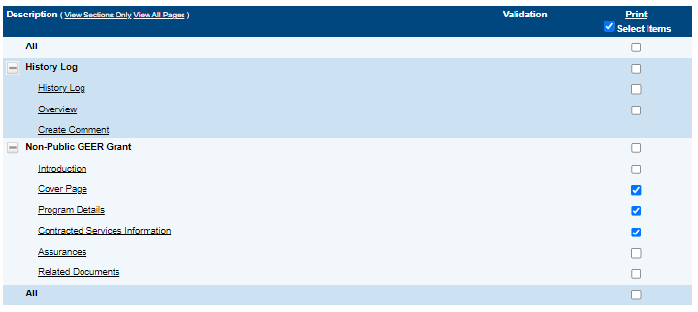
* After ePlan generates the print file, click ***Return to Funding Applications***.

The PDF generated by ePlan appears at the top of the page from the ***TDOE Resources*** menu item. The PDF link remains in ***TDOE Resources*** for five (5) days. Users may use the *“Delete”* links to remove any print jobs.

# Troubleshooting

The following are answers to common questions about ePlan application functionality.

## User Access

If an ePlan user is not able to work in an data and information tool, it is usually due to one of these three reasons:

* The user is not using the Google Chrome browser. For best results: always use Google Chrome to access ePlan. ePlan does not have the same functionality in other browsers.
* The tool is not in the right work step or status. Users can only edit a data and information tool when it is in **Draft Started** or **Revision Started** status.
* The user does not have the right role to work on the data and information tool. When hovering the cursor over **Change Status To** options, a tooltip appears that indicates the roles with access to make the status change. This tooltip will list the names of individual users associated with each permitted role. Users can also access the address book to see which roles an ePlan user has.

ePlan’s address book for each organization contains a list of every user that has an ePlan role.

* The LEA Role Contacts list all the roles. If the role is not listed in the address book, no one has been assigned to that role.
* The LEA Funding Application contacts are contacts selected for a funding application.
  + A contact is not the same as a role. A role assigns access to complete a task in ePlan.
* User Access forms are in ePlan’s TDOE Resources in the User Access Form folder.
  + Users do not need an ePlan role to access TDOE Resources.

See **ePlan User Access** for more information about the ePlan status workflow and user roles.

## Validation Messages

* This feature shows any errors that will prevent an application from moving forward.
* Click the messages under Validation on the Sections page to see any errors or warnings.

## Post-Submission

When users need to revise a data and information tool after changing the status to ***Draft Completed*** prior to the submission deadline, contact the next approver in the workflow and ask that they change the status to ***Not Approved*** to return the application access to the previous user in the workflow. If the tool has proceeded through the workflow to the TDOE Program Director, users can contact the program director or ePlan Help to request that the tool be returned to the previous step in the workflow.

A complete list of ePlan program contacts is available [**here**](https://eplan.tn.gov/DocumentLibrary/ViewDocument.aspx?DocumentKey=1324404&inline=true).

## Inbox

Several ePlan functions automatically generate emails which the system sends to users. The **Create Comment** function prompts ePlan to send an email message to the selected recipients. And, **System Notifications** are sent to users because of a **Status Change** to support **Workflows**.

All email messages sent or received by a user through ePlan can be accessed from the **Inbox**. The **Inbox** section of ePlan contains the **Email Message Archive** and **Items Awaiting Approval**. The **Email Message Archive** will contain all emails sent to or received from another ePlan user through the system. Users may select the time period to display. Messages received by the user will appear first; scroll down to the lower half of the page to view sent messages. Comments with email notifications can be accessed from the **Inbox** in addition to the **History Log** section of the data and information tool.

When a **System Notification** is generated related to a **Status Change** that requires the user to complete an approval step, users will find these in **Items Awaiting Approval**.