2025 APR Local Determinations

1. Any district user with a district role can upload or download to the LEA Document Library.
   1. The [LEA User Access Form](https://eplan.tn.gov/DocumentLibrary/ViewDocument.aspx?DocumentKey=1511231&inline=true) has the roles that will allow a user to have access to the LEA Document Library.
   2. A login is not needed to access TDOE Resources.
   3. Here is a screenshot of the form, showing a common role of **LEA Data View** role, which allows a user to upload and download from ePlan’s LEA Document Library.

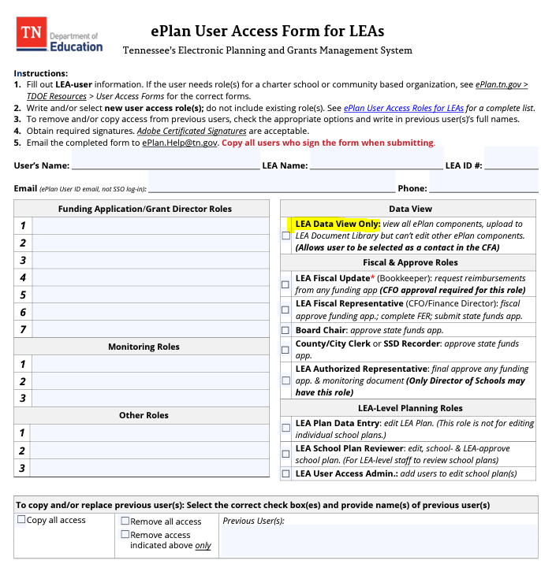

1. Any user with an ePlan role will select the LEA Document Library from the main menu.

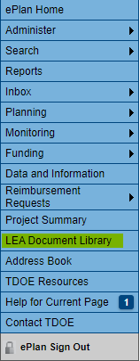

1. To open the 2025 LEA Document Library, click on 2025 and hit show folders. Then click the + in front of the 2025 as shown below.

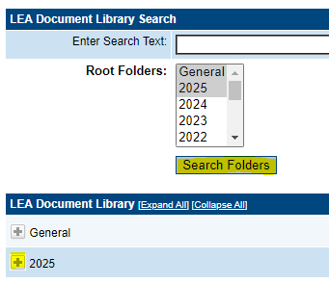

1. Click the + to open this 2025 Annual Performance Report.

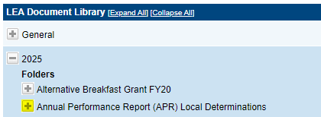

1. There are 4 subfolders here.
   1. FFY 2023 (2023-24 SY)
   2. Historical Data
   3. APR Indicators Corrective Actions

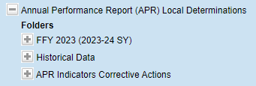

1. Click on the + to open these folders.

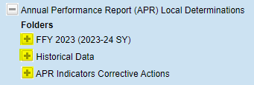

1. Each folder has the documents.

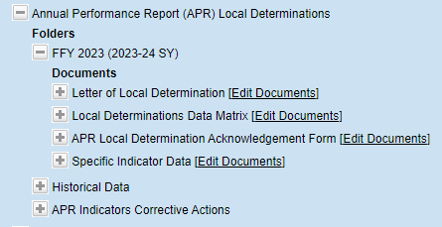

1. To view the uploaded documents, click the + in from of the documents.

