**District User Access Administrators Functions**

**Adding or Removing School Level Users**

District user access adminstrators can assign or delete school level roles.

* School Plan Data Entry – These users edit and submit school plans. These users are usually assistant principals or other school personnel.
* School Plan Reviewer – These users review and approve or not approve school plans. These are usually principals.

Here are the steps to add or remove roles for a school level user.

1. Hover over the Administer and select User Access

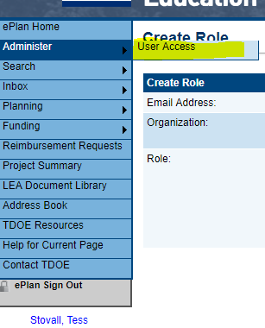

1. Type in the last name and hit search.
   1. You then select the note for Administer Roles as highlighted below.
   2. Typing in the user’s email address can also be done for this search.

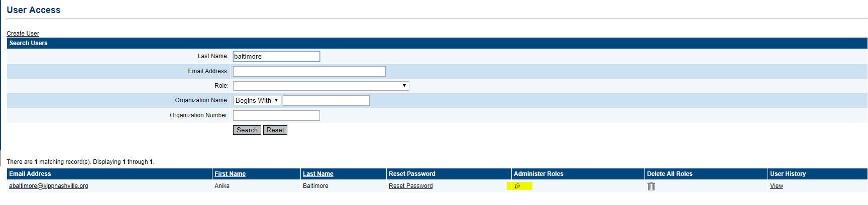

1. The next screen allows for the create roles to happen.

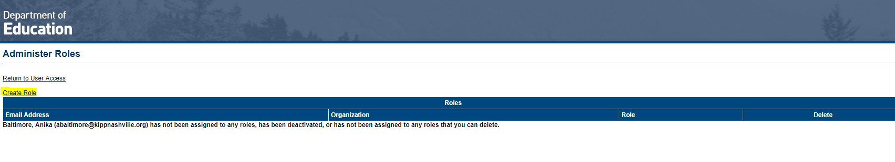

1. If this individual is not registered in ePlan, you can hit the Create user to add them as a new user.

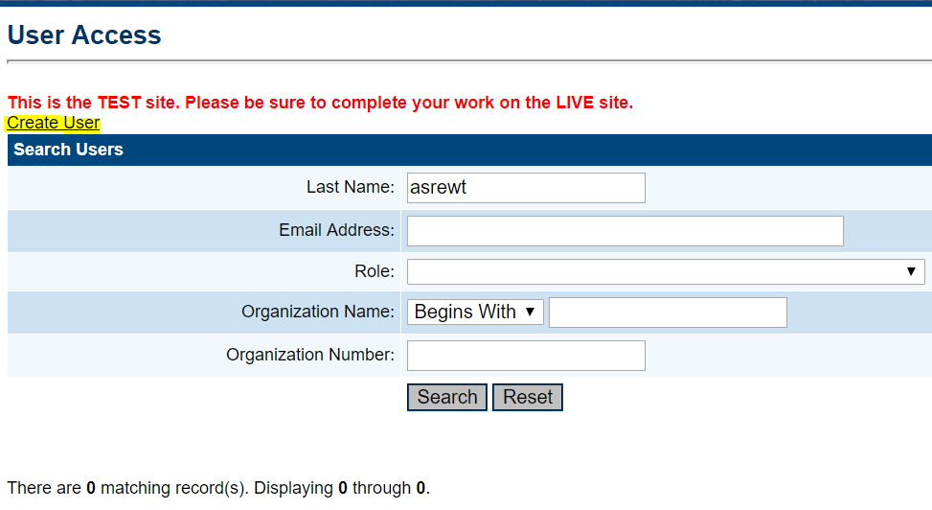

The next step to create a user is to enter their contact information and then hit Create.

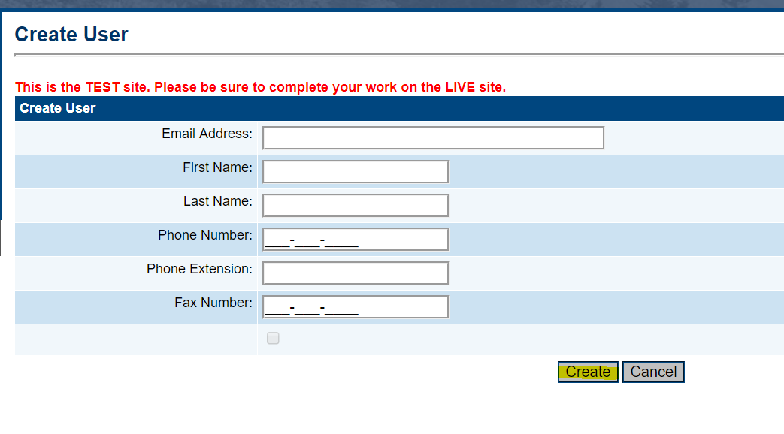

Click the administer roles as shown in step 2 to add the roles.

1. The next screen will show if there are current roles for this user. You select the Create Role as highlighted below to go to the next screen and give this individual a new role.

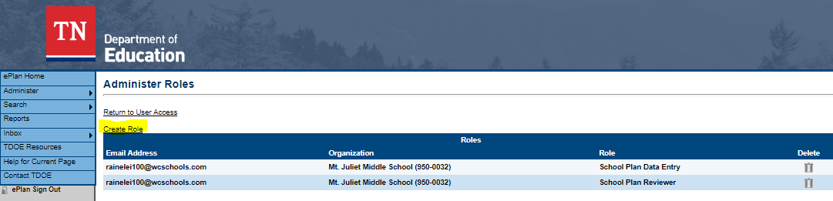

1. When the create role screen loads you can select the following:
   1. The school this person should be assigned the roles.
   2. Select the roles for the individual; the School Plan Data Entry and/or School Plan Reviewer.
   3. If you click in the box to the left of the role names, a check mark will appear in that box, and you can then hit create.

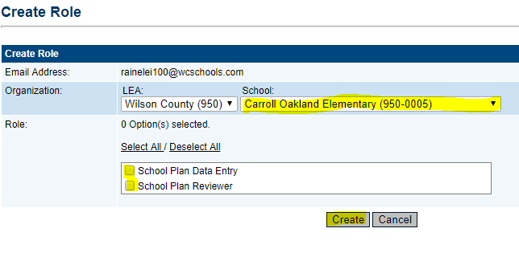

1. If you need to remove a role from an individual, select the trashcan next to the role that needs removed.

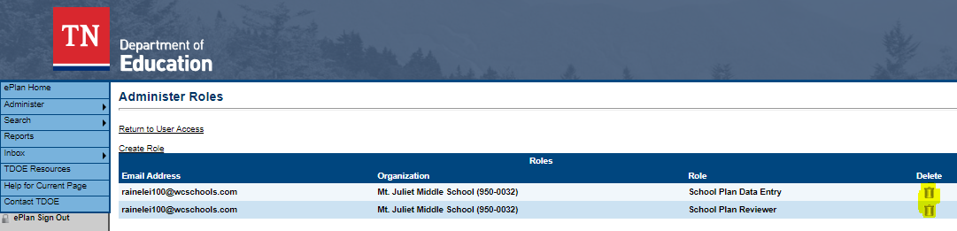

1. If you go back and look at the user’s roles, you should then see the new roles added or removed.
2. This only works for school level roles. Any role with LEA at the beginning can only be added or removed by the ePlan help team.

**Contact Information**

User access administrators can also update contact information and send password resets to users that do no use Orion Single Sign On (SSO).

Here are the steps to update contact information.

1. Search for the user first.

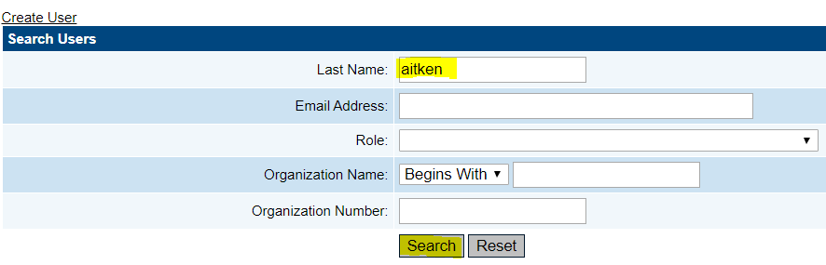

1. Click on the underlined name. If the reset password column shows Password Set in TDOE Orion the user’s information cannot be updated. Alexander and John Aitken from the example found below could not have their information updated.

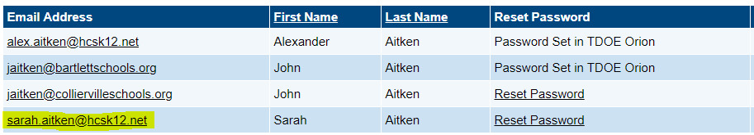

1. The next screen will contain all the contact information for this user.
   1. Any of the contact information can be changed.
   2. Click **Update** to save the changes.
   3. Please note if the *Linked to TDOE Orion* has a check next to it, no information can be updated.

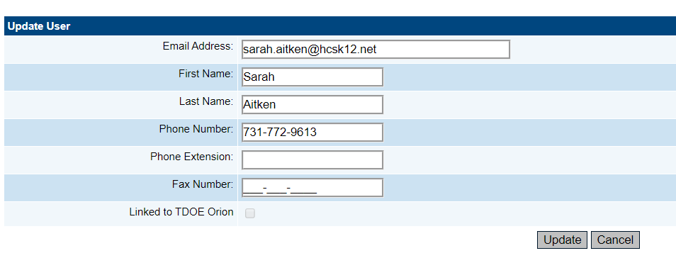

**Resetting a password.**

Users that do not use Orion SSO can have a password reset link sent to their email to reset their ePlan password. There are 2 ways a user can have this link sent to their email address.

1. A user access administrator can click the **Reset Password** after searching for the user.

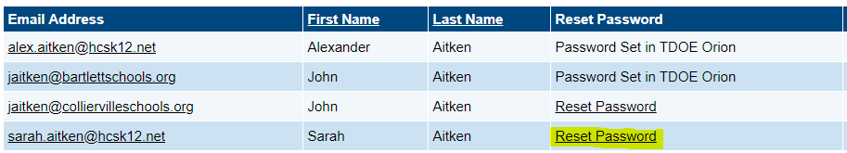

1. Users can also send this same link to their email address by clicking the **Forgot your password** link on the sign in page.

